**CMPS 350 Project Phase 1 – Report**

**Education Platform**

**(10% of the course grade)**

**The report must be submitted in Word format only**

|  |  |
| --- | --- |
| **Group Members** | Ghanim Mubarak Alkuwari (202208523)  Fahrel Azki Hidayat (202206836)  Mohammed Alam (202211429)  AbdulWasay Saqib (202211598)  **Emails:**  ga2208523@qu.edu.qa  fh2206836@qu.edu.qa  ma2211429@qu.edu.qa  aw2211598@qu.edu.qa |
| **GitHub link** | <https://github.com/fahrel-fh2206836/student-management-app> |

**Grades :**

**The student fills only the “Implementation Percentage”: Please specify either: *Working (completed x%)*, *Not Working (completed x%)* or *Not done*.**

|  |  |  |  |  |
| --- | --- | --- | --- | --- |
| **Criteria** | **Points** | **Implementation Percentage** | **Implementation Quality** | **Your Grade** |
| Design and implement the app Web UI and navigation using HTML, CSS and JavaScript. Including designing the App Web UI and navigation. | 50 | Working (completed 100%) |  |  |
| Design and implement the Web API and data access repositories to read/write the app data JSON files. | 30 | Working (completed 100%) |  |  |
| Application modeling (e.g. UML diagrams) to explain the data entities and the functionalities | 5 | Working (completed 100%) |  |  |
| Testing documentation using screen shots illustrating the testing results. | 5 | Working (completed 100%) |  |  |
| Team work quality. Contributions of team members - All members should collaborate and contribute equally to the project. | 5 | Working (completed 100%) |  |  |
| Project report – description of the implemented app, what is implemented, what is missed .. | 5 | Working (completed 100%) |  |  |
| **Total** | 100 |  |  |  |
| **Plagiarism, outsourcing, free riders** | -100 |  |  |  |
| **Delivery behind the deadline** | -5 |  |  |  |

**Important remark: In case of copying and/or plagiarism or not being able to explain or answer questions about the implementation, you lose the whole grade.**

**\* Criteria for grading the functionality:**

- The functionality is working: you get 70% of the assigned grade.

- The functionality is not working: you lose 40% of assigned grade.

- The functionality is not implemented: you get 0.

- The remaining grade in all cases from above **is assigned to the quality of the implementation**,

- The grades are distributed on the various use cases, when the design/implementation is partial, you get only the grades of designed/implemented use cases.

Code quality criteria, include:

- Use of meaningful identifiers for variables and functions (e.g. using JavaScript naming conventions)

- Pages are responsive

- Clean code: simple and concise code, no redundancy

- Clean implementation without unnecessary files/code

- Use of comments where necessary

- Proper code formatting and indentation.

**You lose marks** for code duplication, poor/inefficient coding practices, poor naming of identifiers, unclean/untidy submission, and unnecessary complex/poor user interface design.

**Important Remark**:

**[Grades: 100-85]:** Will be given only to **fully functional application** with **all the quality criteria cited above met** and the project has excellent **design for the various functionalities**. **The report is professional**.

**[Grades: 85-80]:** Will be given only **to functional application** **with most of all the quality criteria cited above met** and the project has good design for the various functionalities. **The report is professional**.

**[Grades: 80-75]:** 80% of the application functionalities are functional. The project respects partially the quality criteria. **The report is professional** but misses some information.

The grades are not negotiable. We expect that only a small portion (around 15%) of the class will be able to meet the criteria for the grades **[100-85]. You should work hard to and demonstrate the merits of your application to earn those grades.+**

# Description of your proposed platform

A Platform for course management with three different types of users that can login into the system: Admin, Student, Instructors.

Admins can View All Courses and Sections, Add Courses, Add sections of a course, View Weekly Schedules of all Courses, and Manage courses which include editing courses and section’s status and validating sections to be approved.

Students can View their Ongoing Courses, Browse and Filter other courses, View and Register sections of a course, and View their learning path which includes their progress statistics (Credit hour completed etc.) and list of courses they have completed, In-progress, and pending.

Instructors can View their previous, future, and ongoing teaching sections and Submit student grades of a section.

# Application Design

# Use case diagram

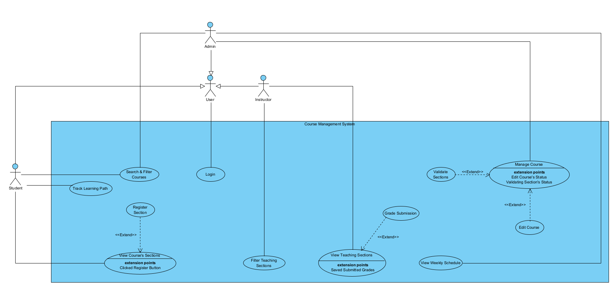

# Entities class diagram

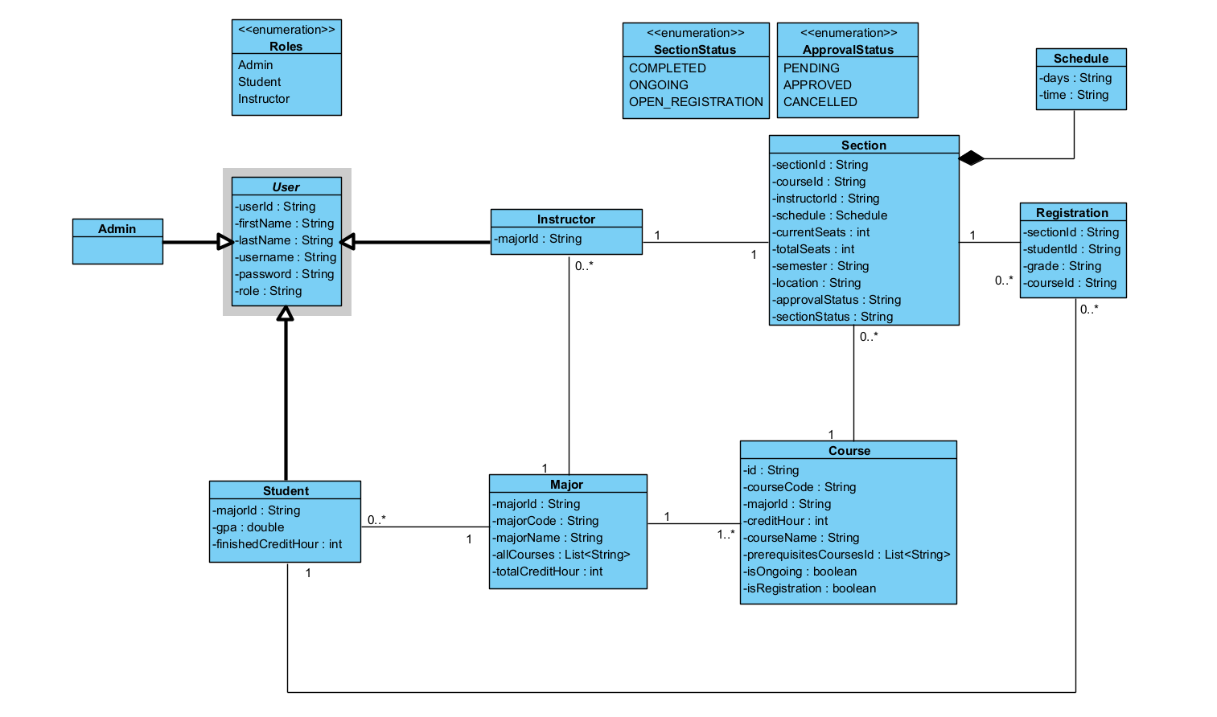

# Web API class

**Web API was not Implemented.**

# Webpage UI Skecthes

**UI sketches can be found in the repo under Diagrams/UI SKECTH.pdf**

# Implementation

# Implemented use-cases

**All Use cases (1,2,3,4,5,6,8) were implemented and functional.**

# Unimplemented use-cases and not functioning parts

**All Use cases (1,2,3,4,5,6,8) were implemented and functional.**

# Testing

# Use case 1

Login Page & Incorrect Login:

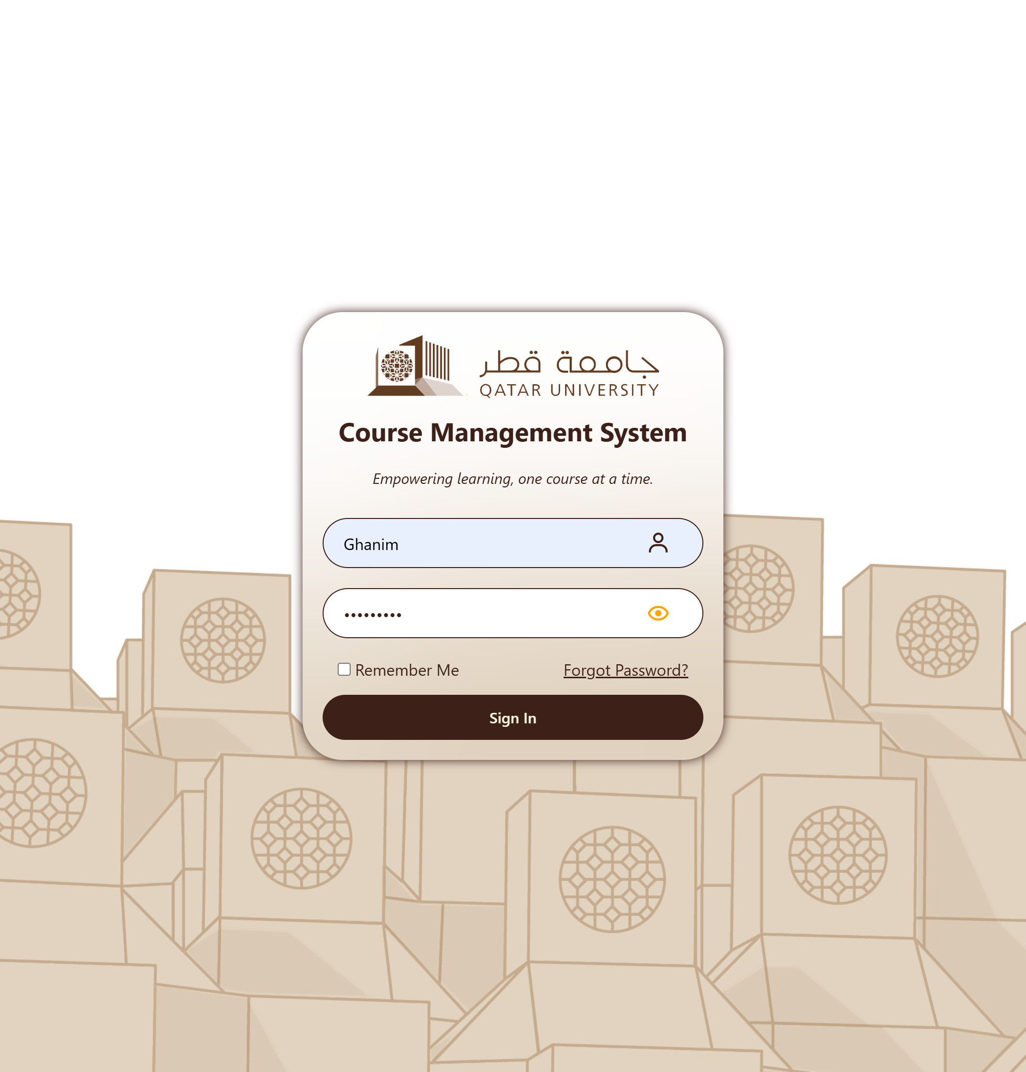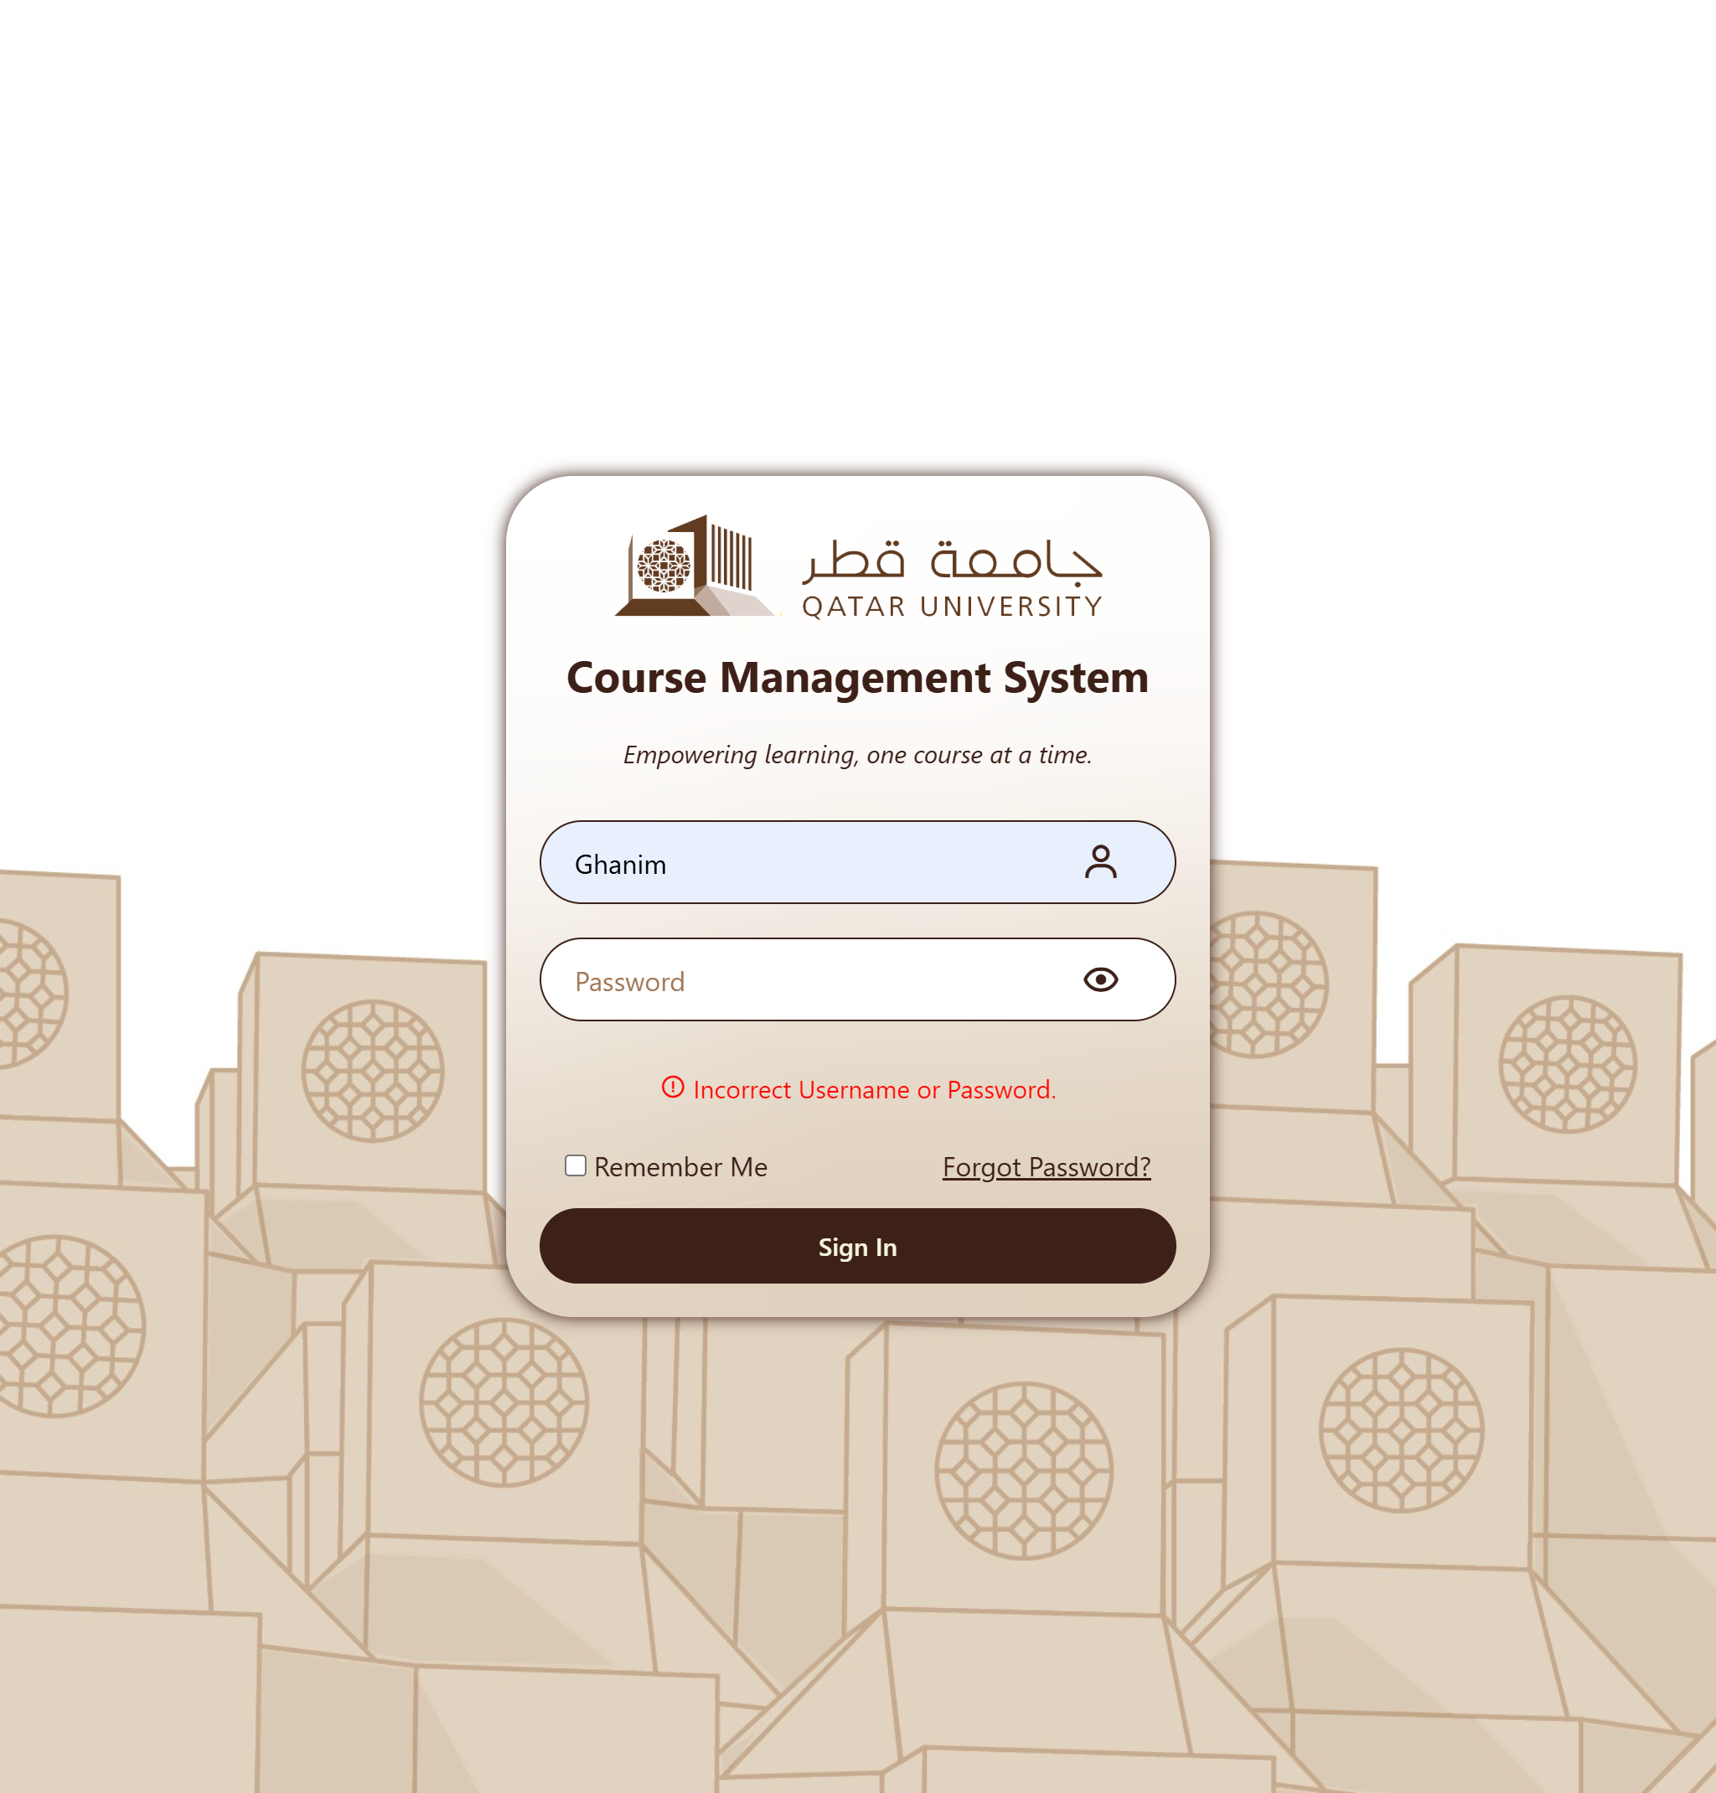

# Use case 2

Laptop View & Mobile View:

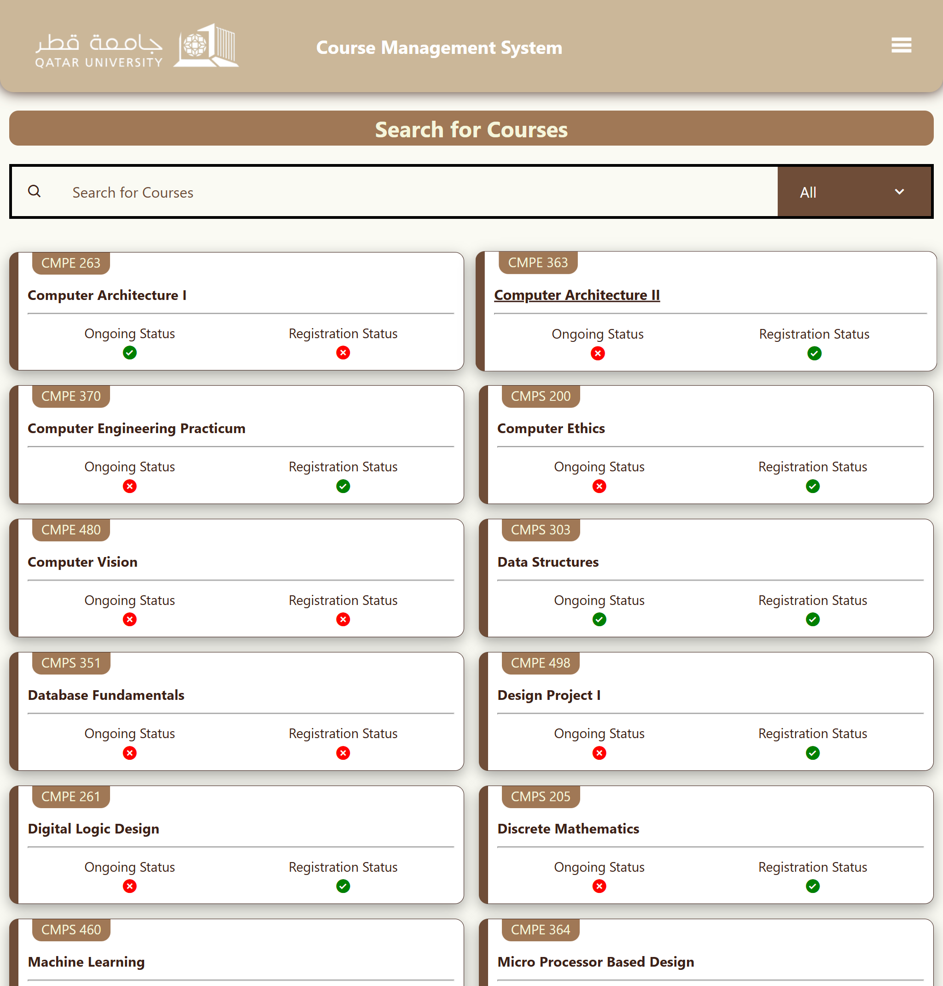 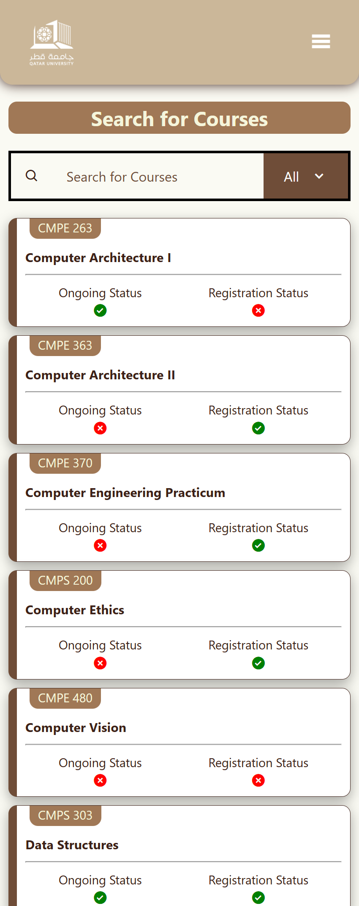

Search Filter (Searching ‘Comp’):

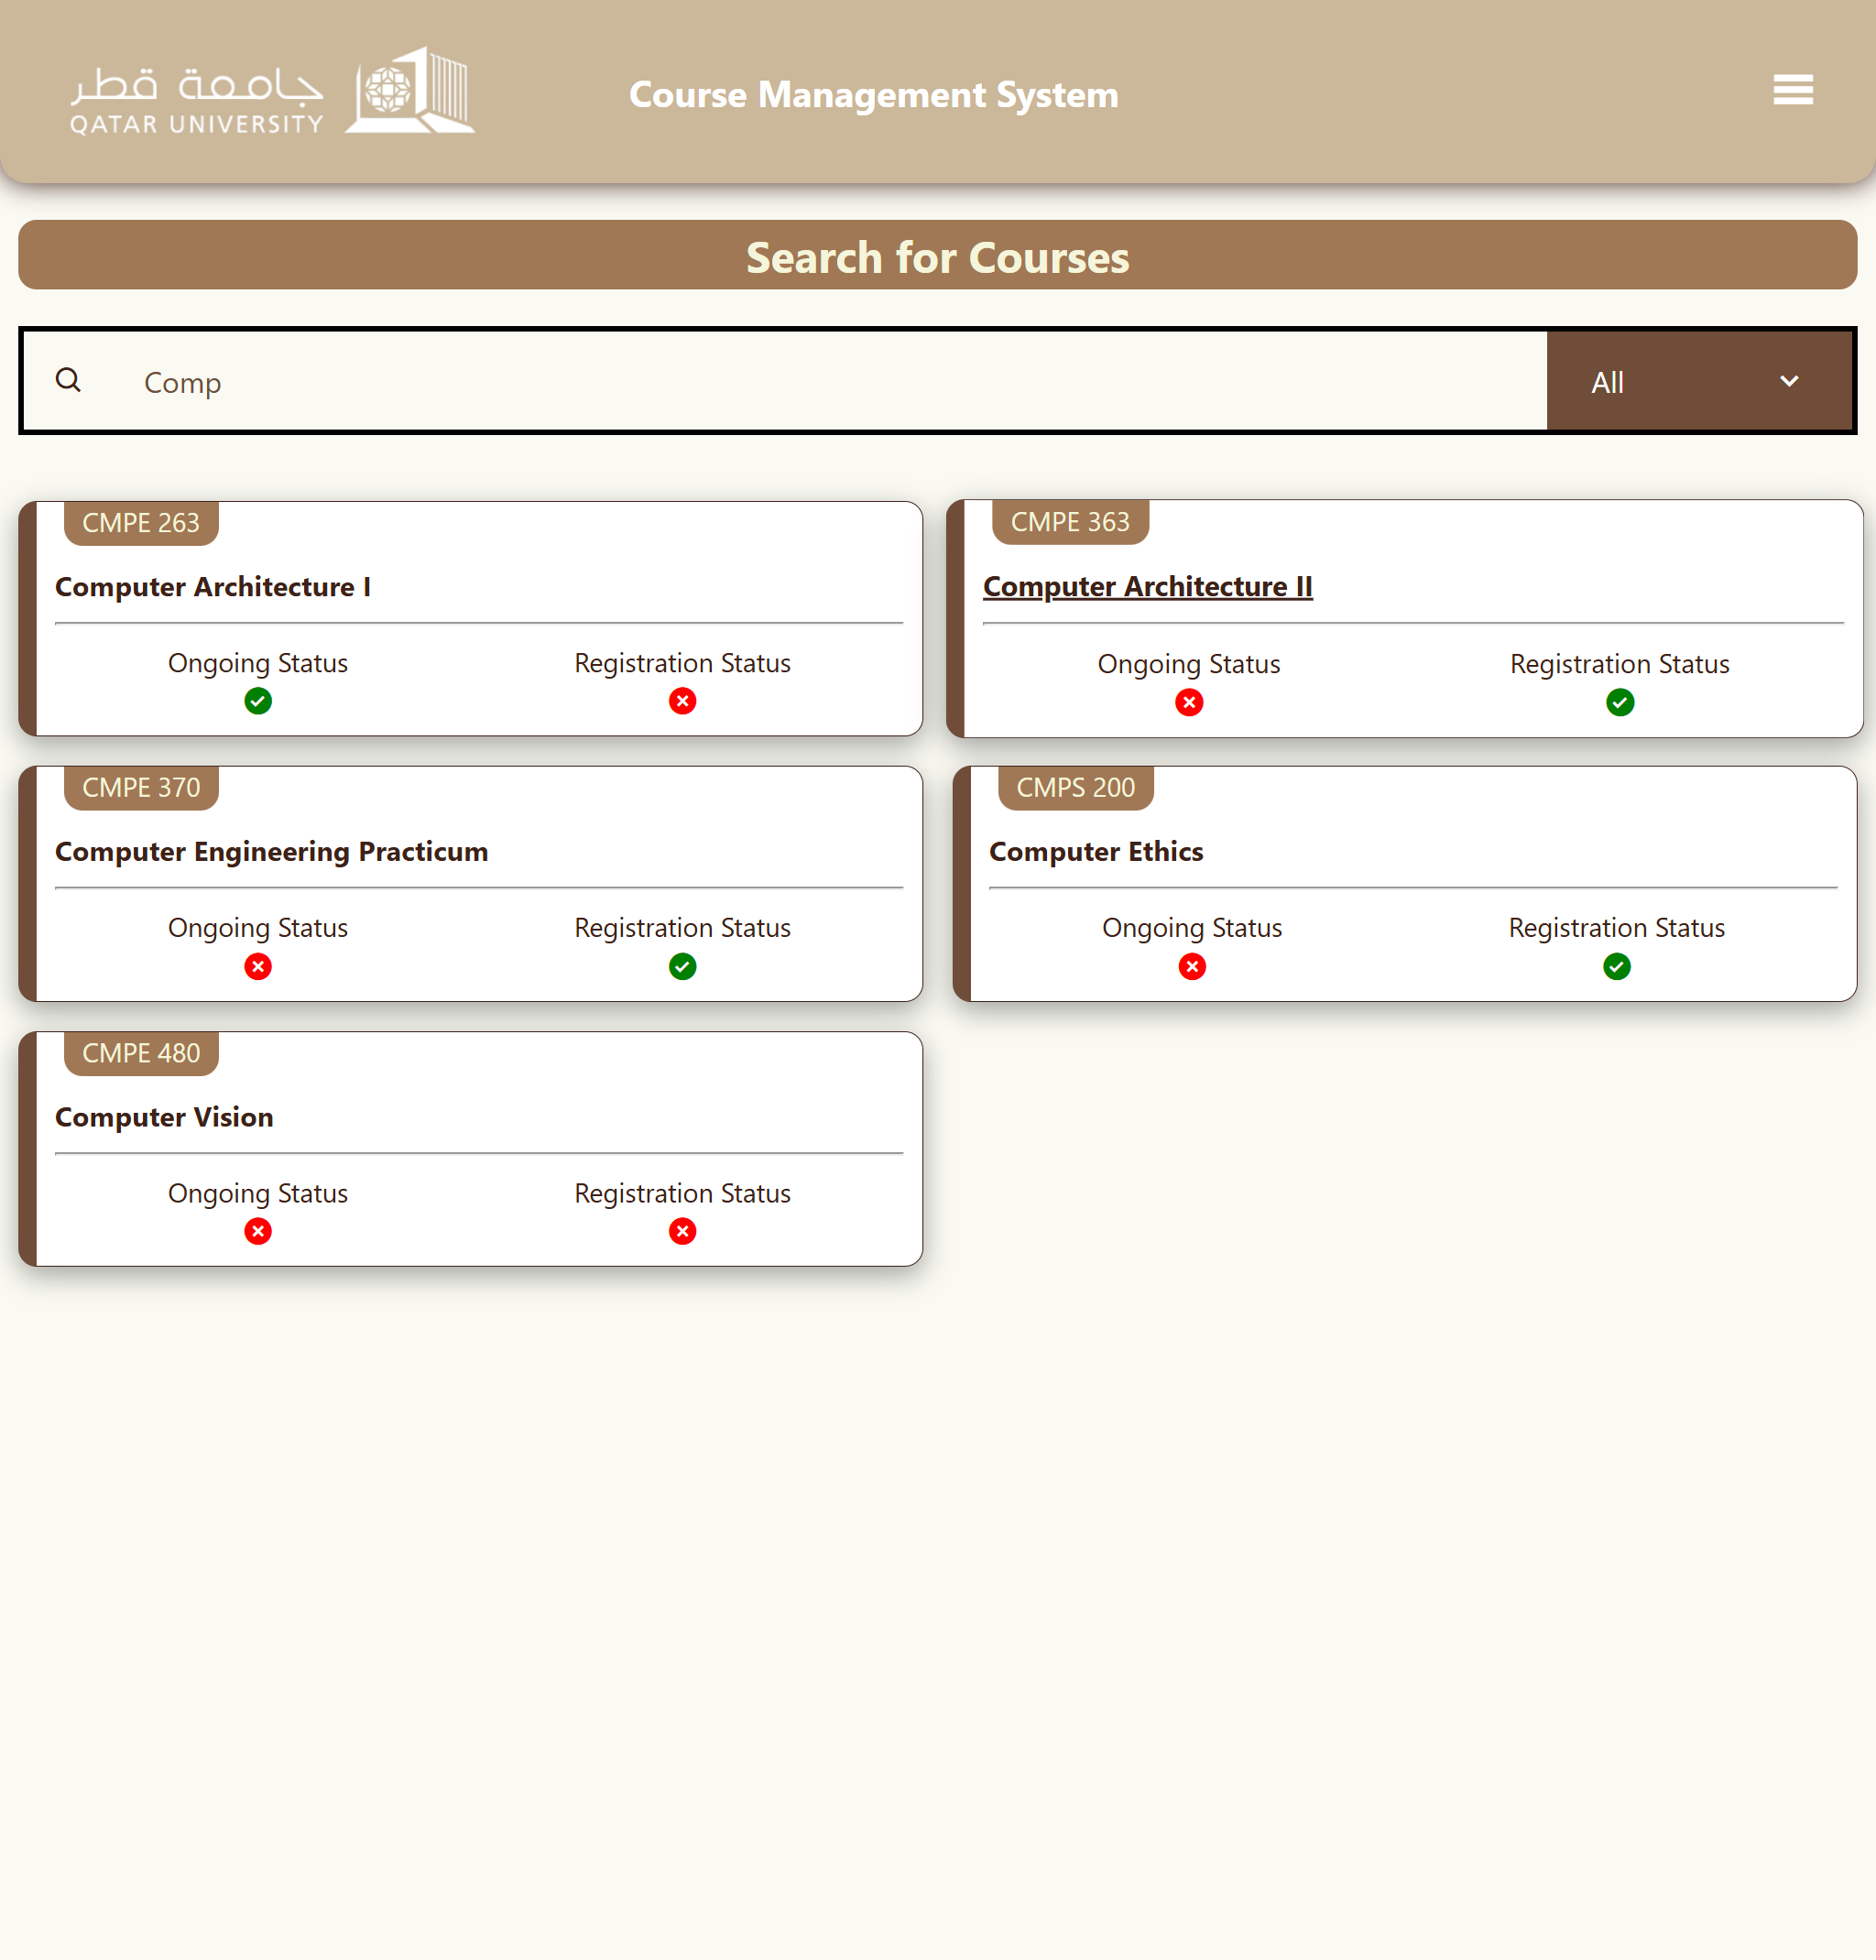

Filter by Major (Searching ‘Comp’ and Filter ‘CMPS’):

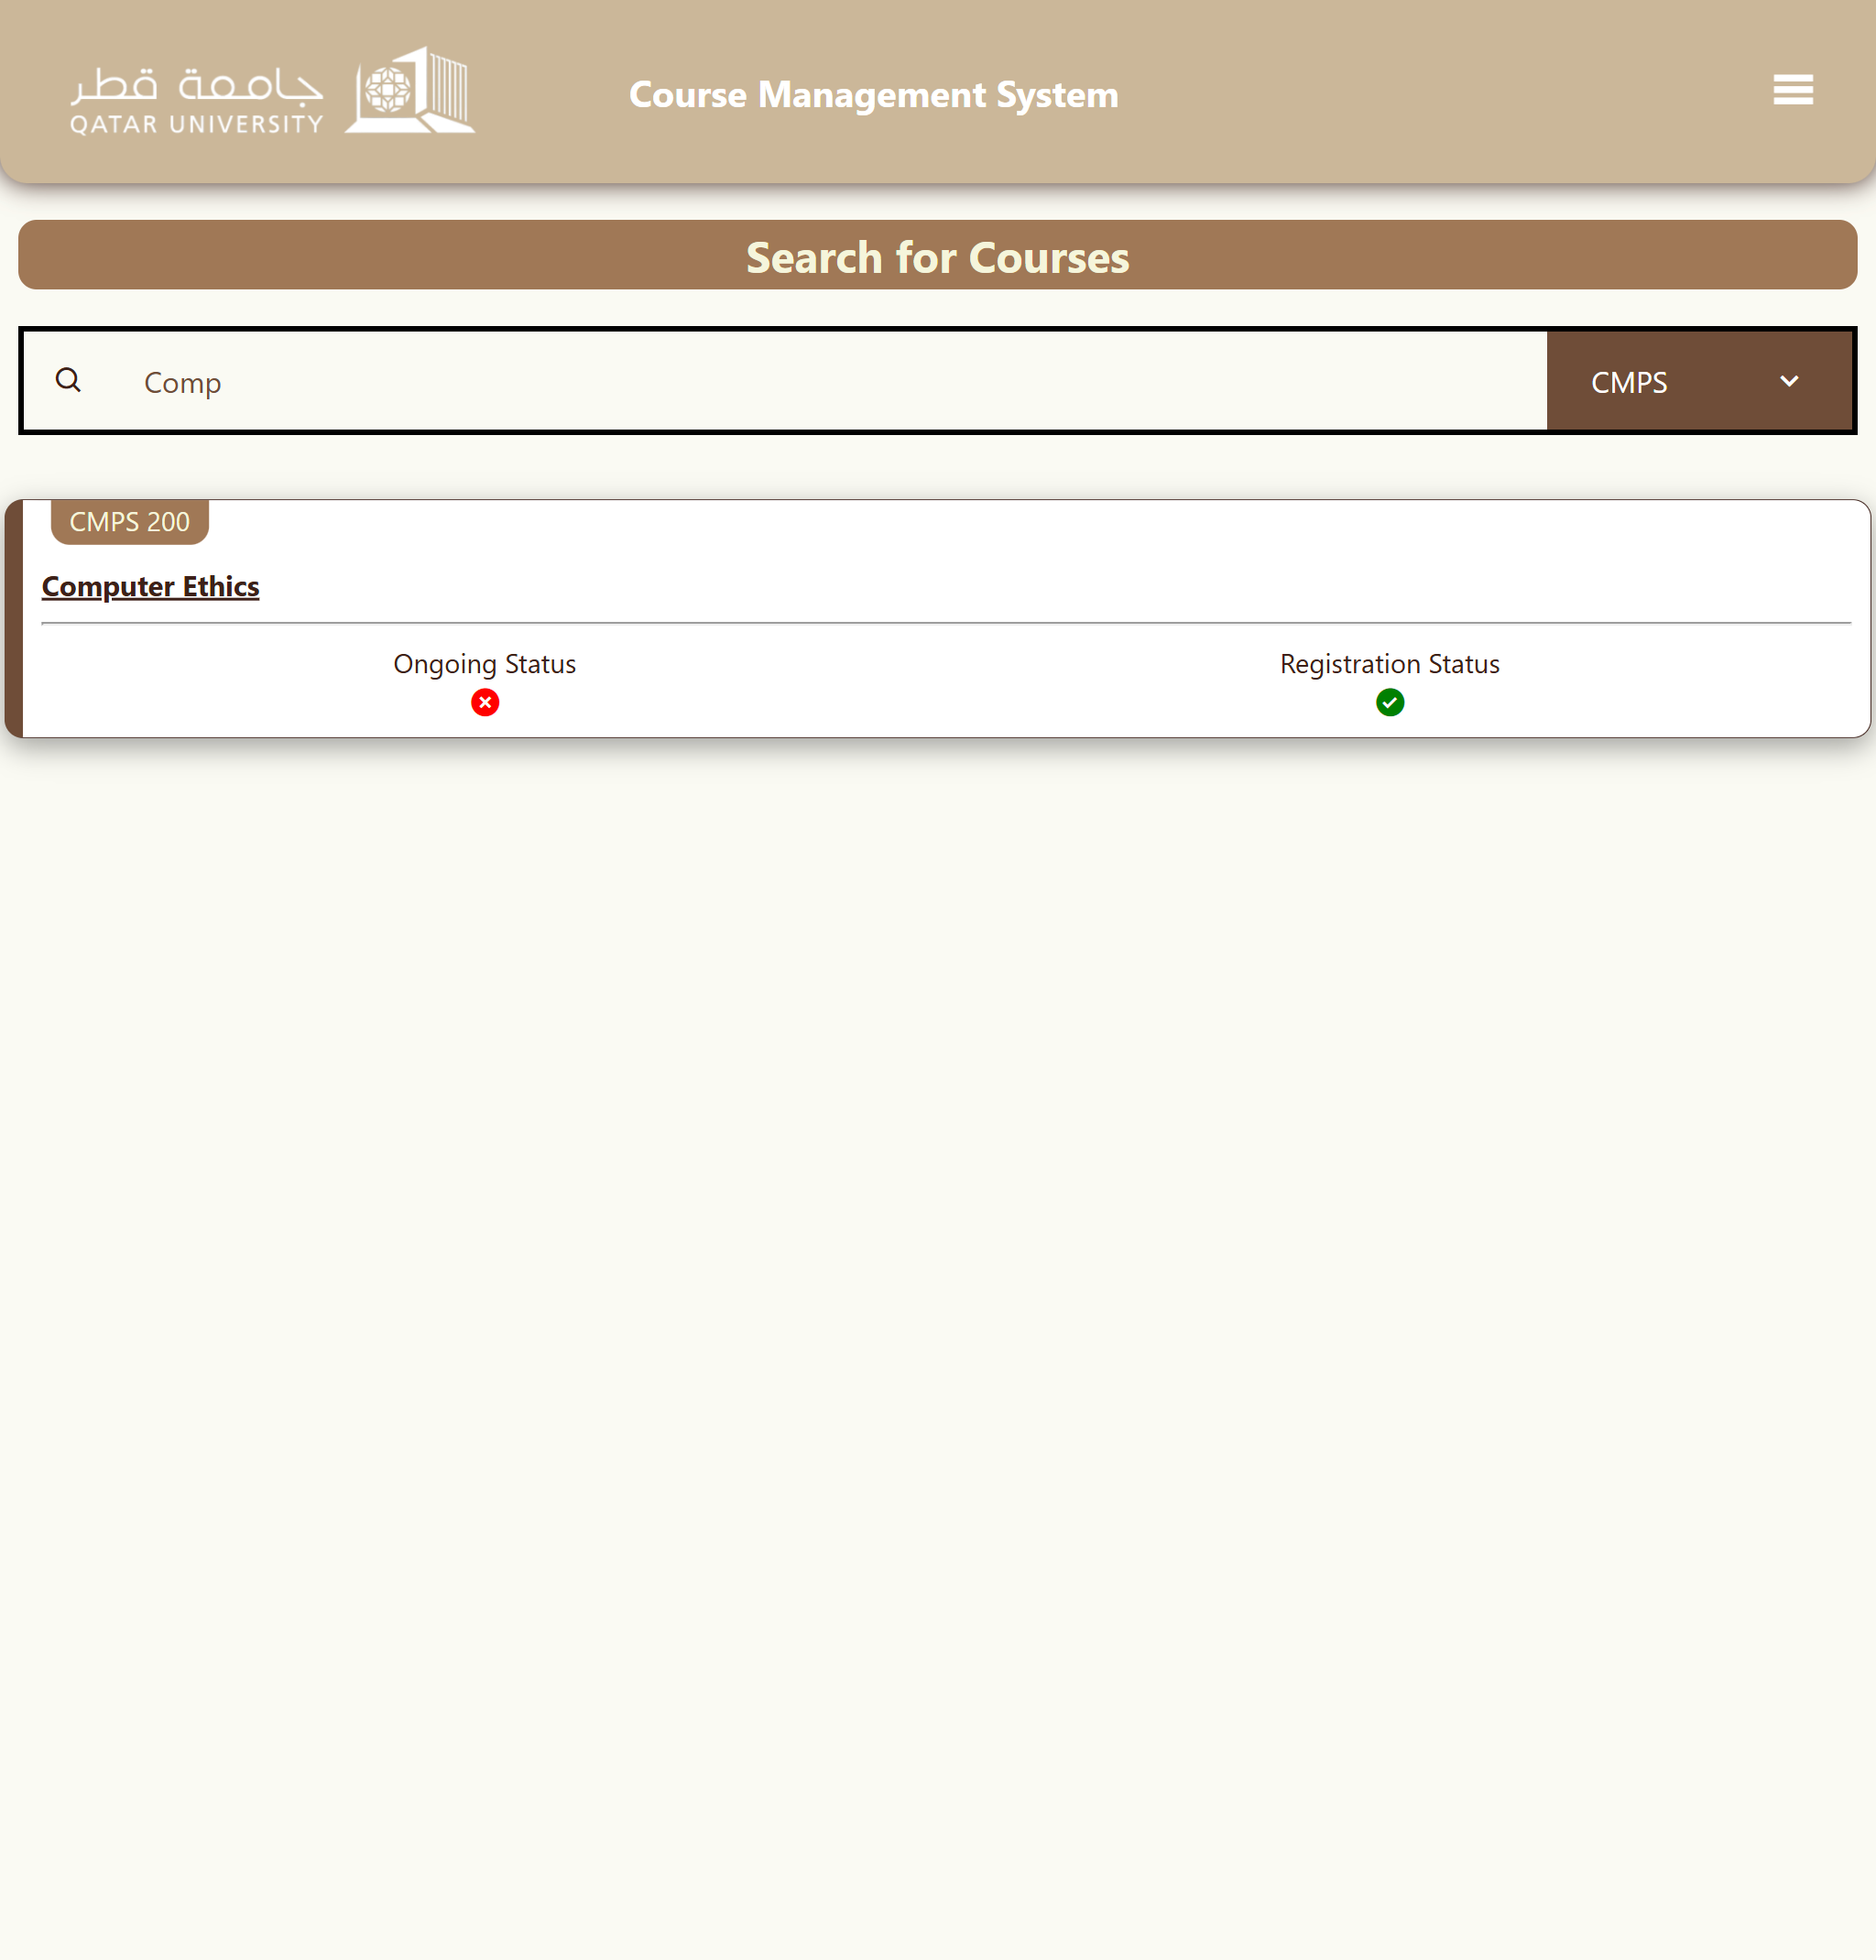

Filter by Major (Searching ‘comp’ and Filter ‘CMPE):

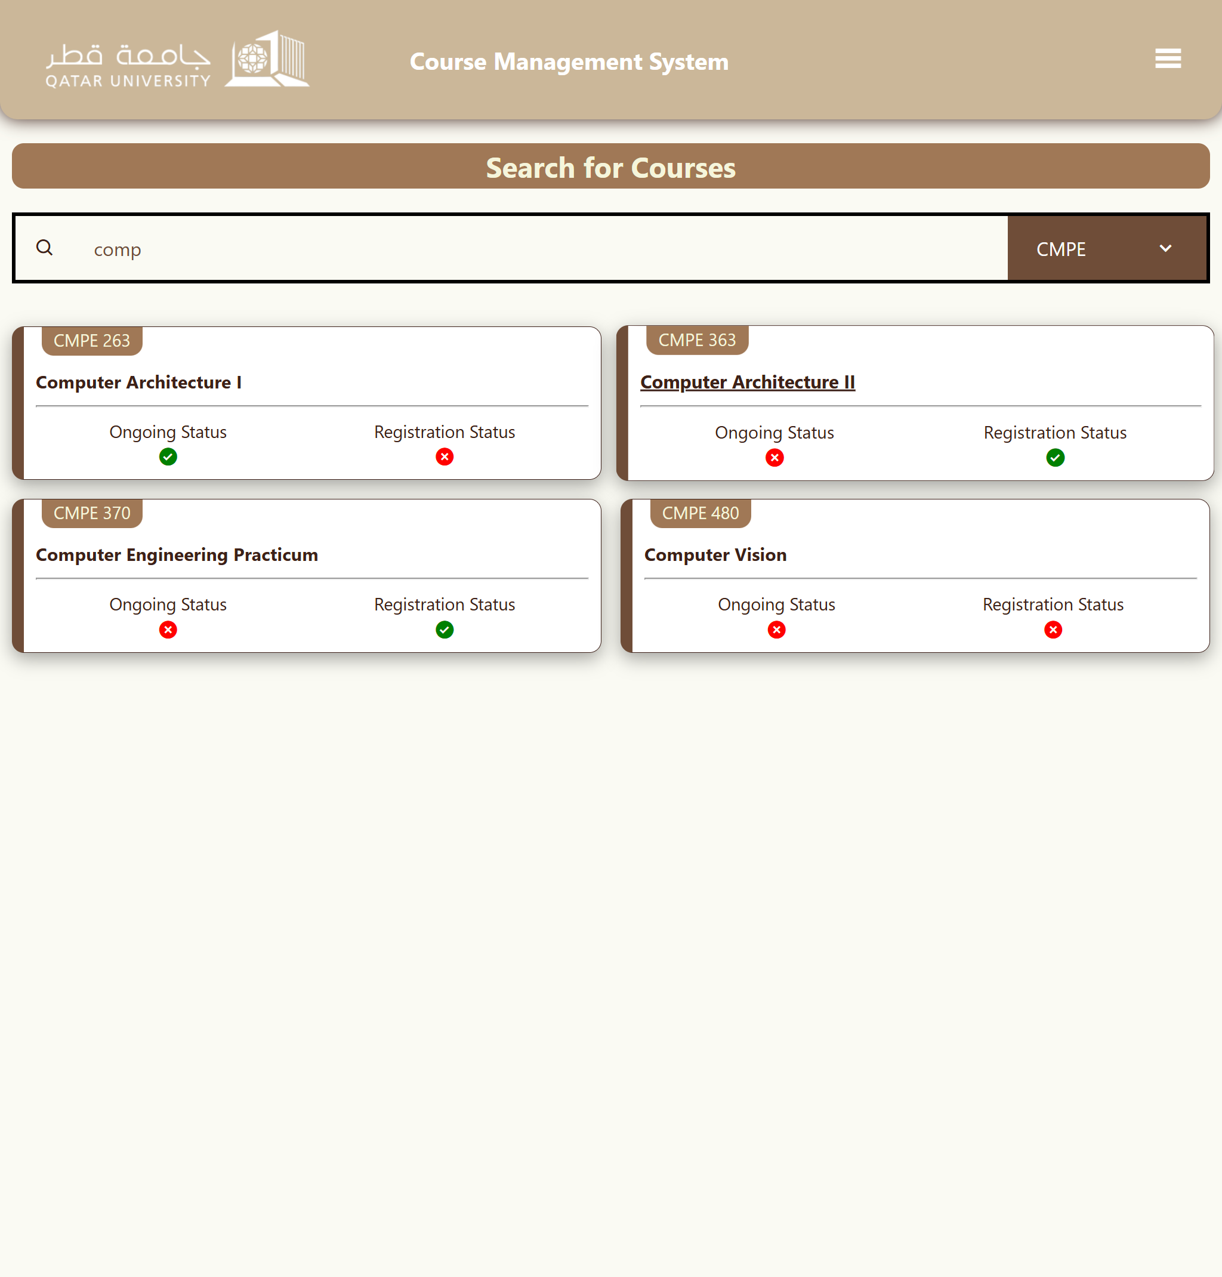

# Use case 3

Mobile & Laptop View:

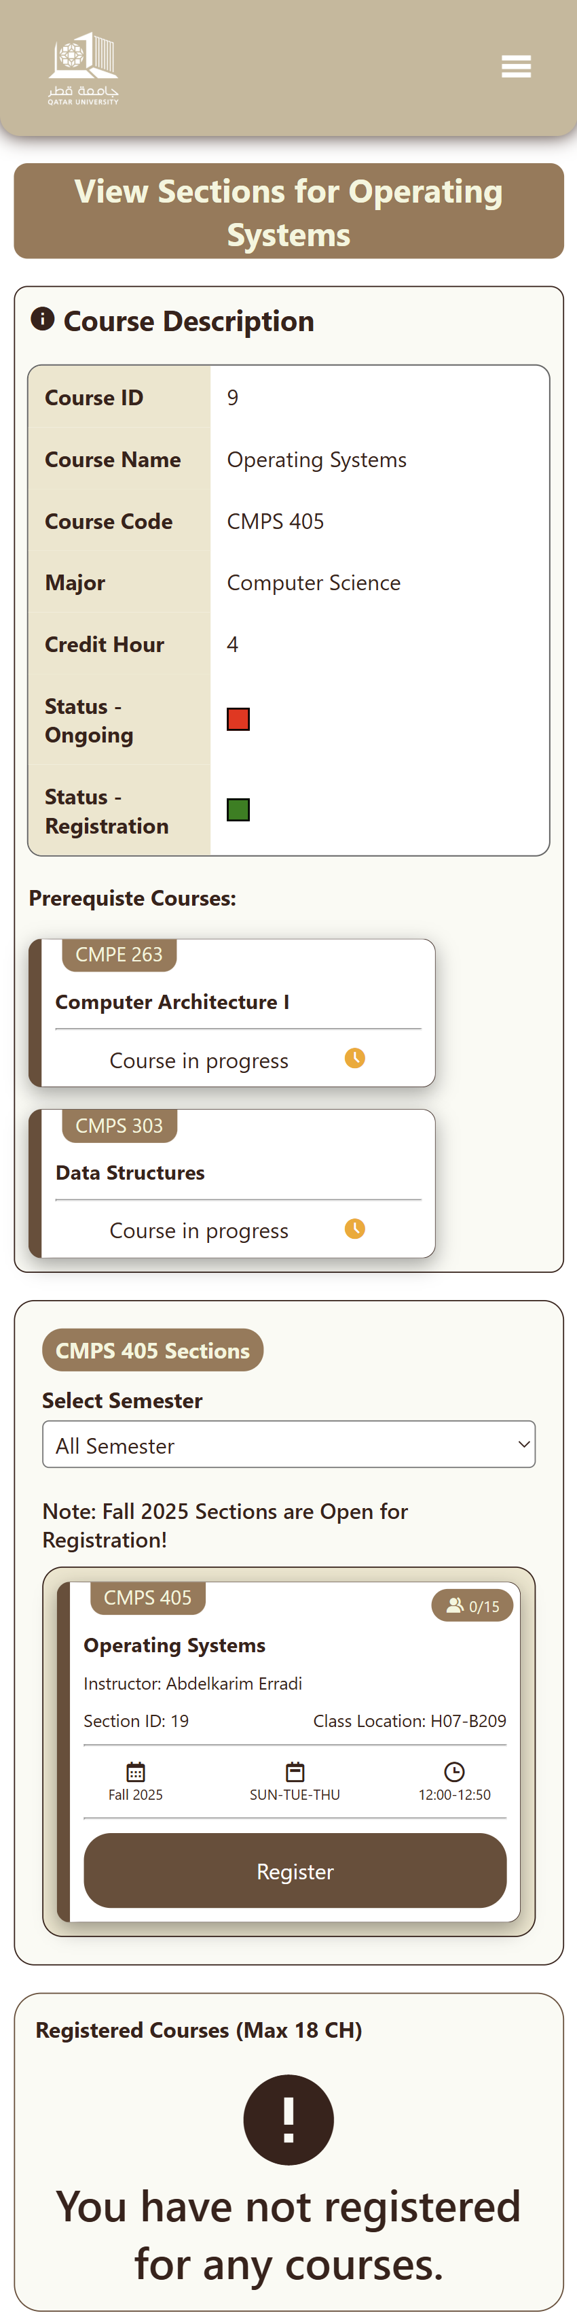 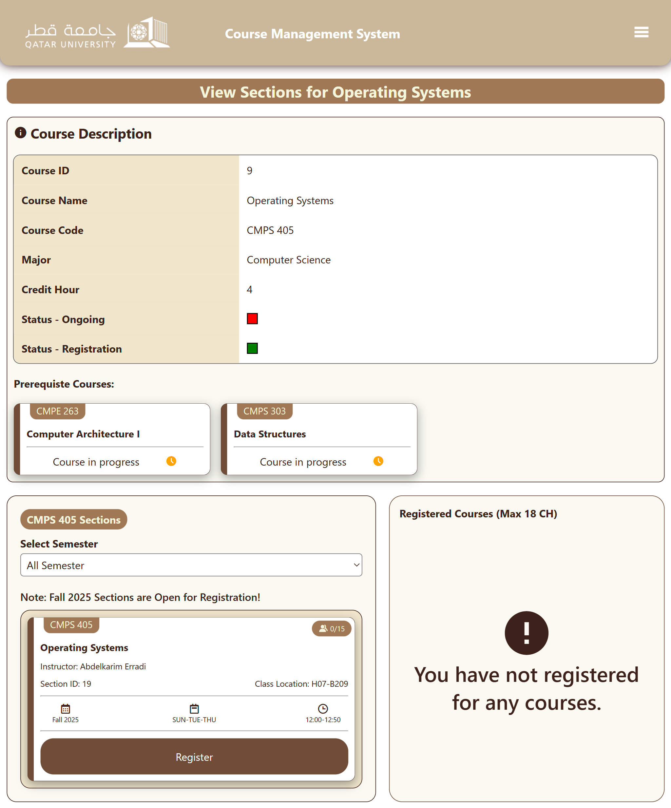

Registering for a course that is not open for registration (Register button is gray):

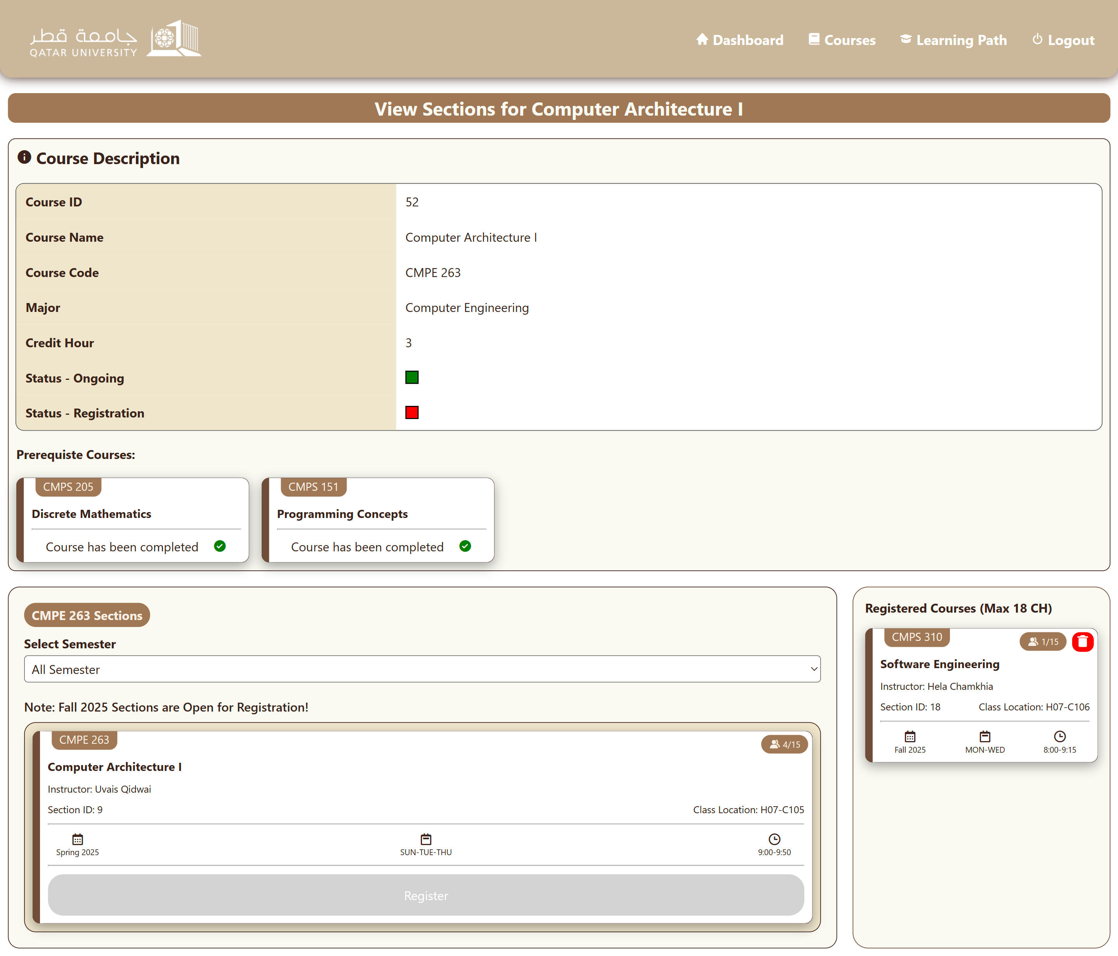

Registering for a course that is full:

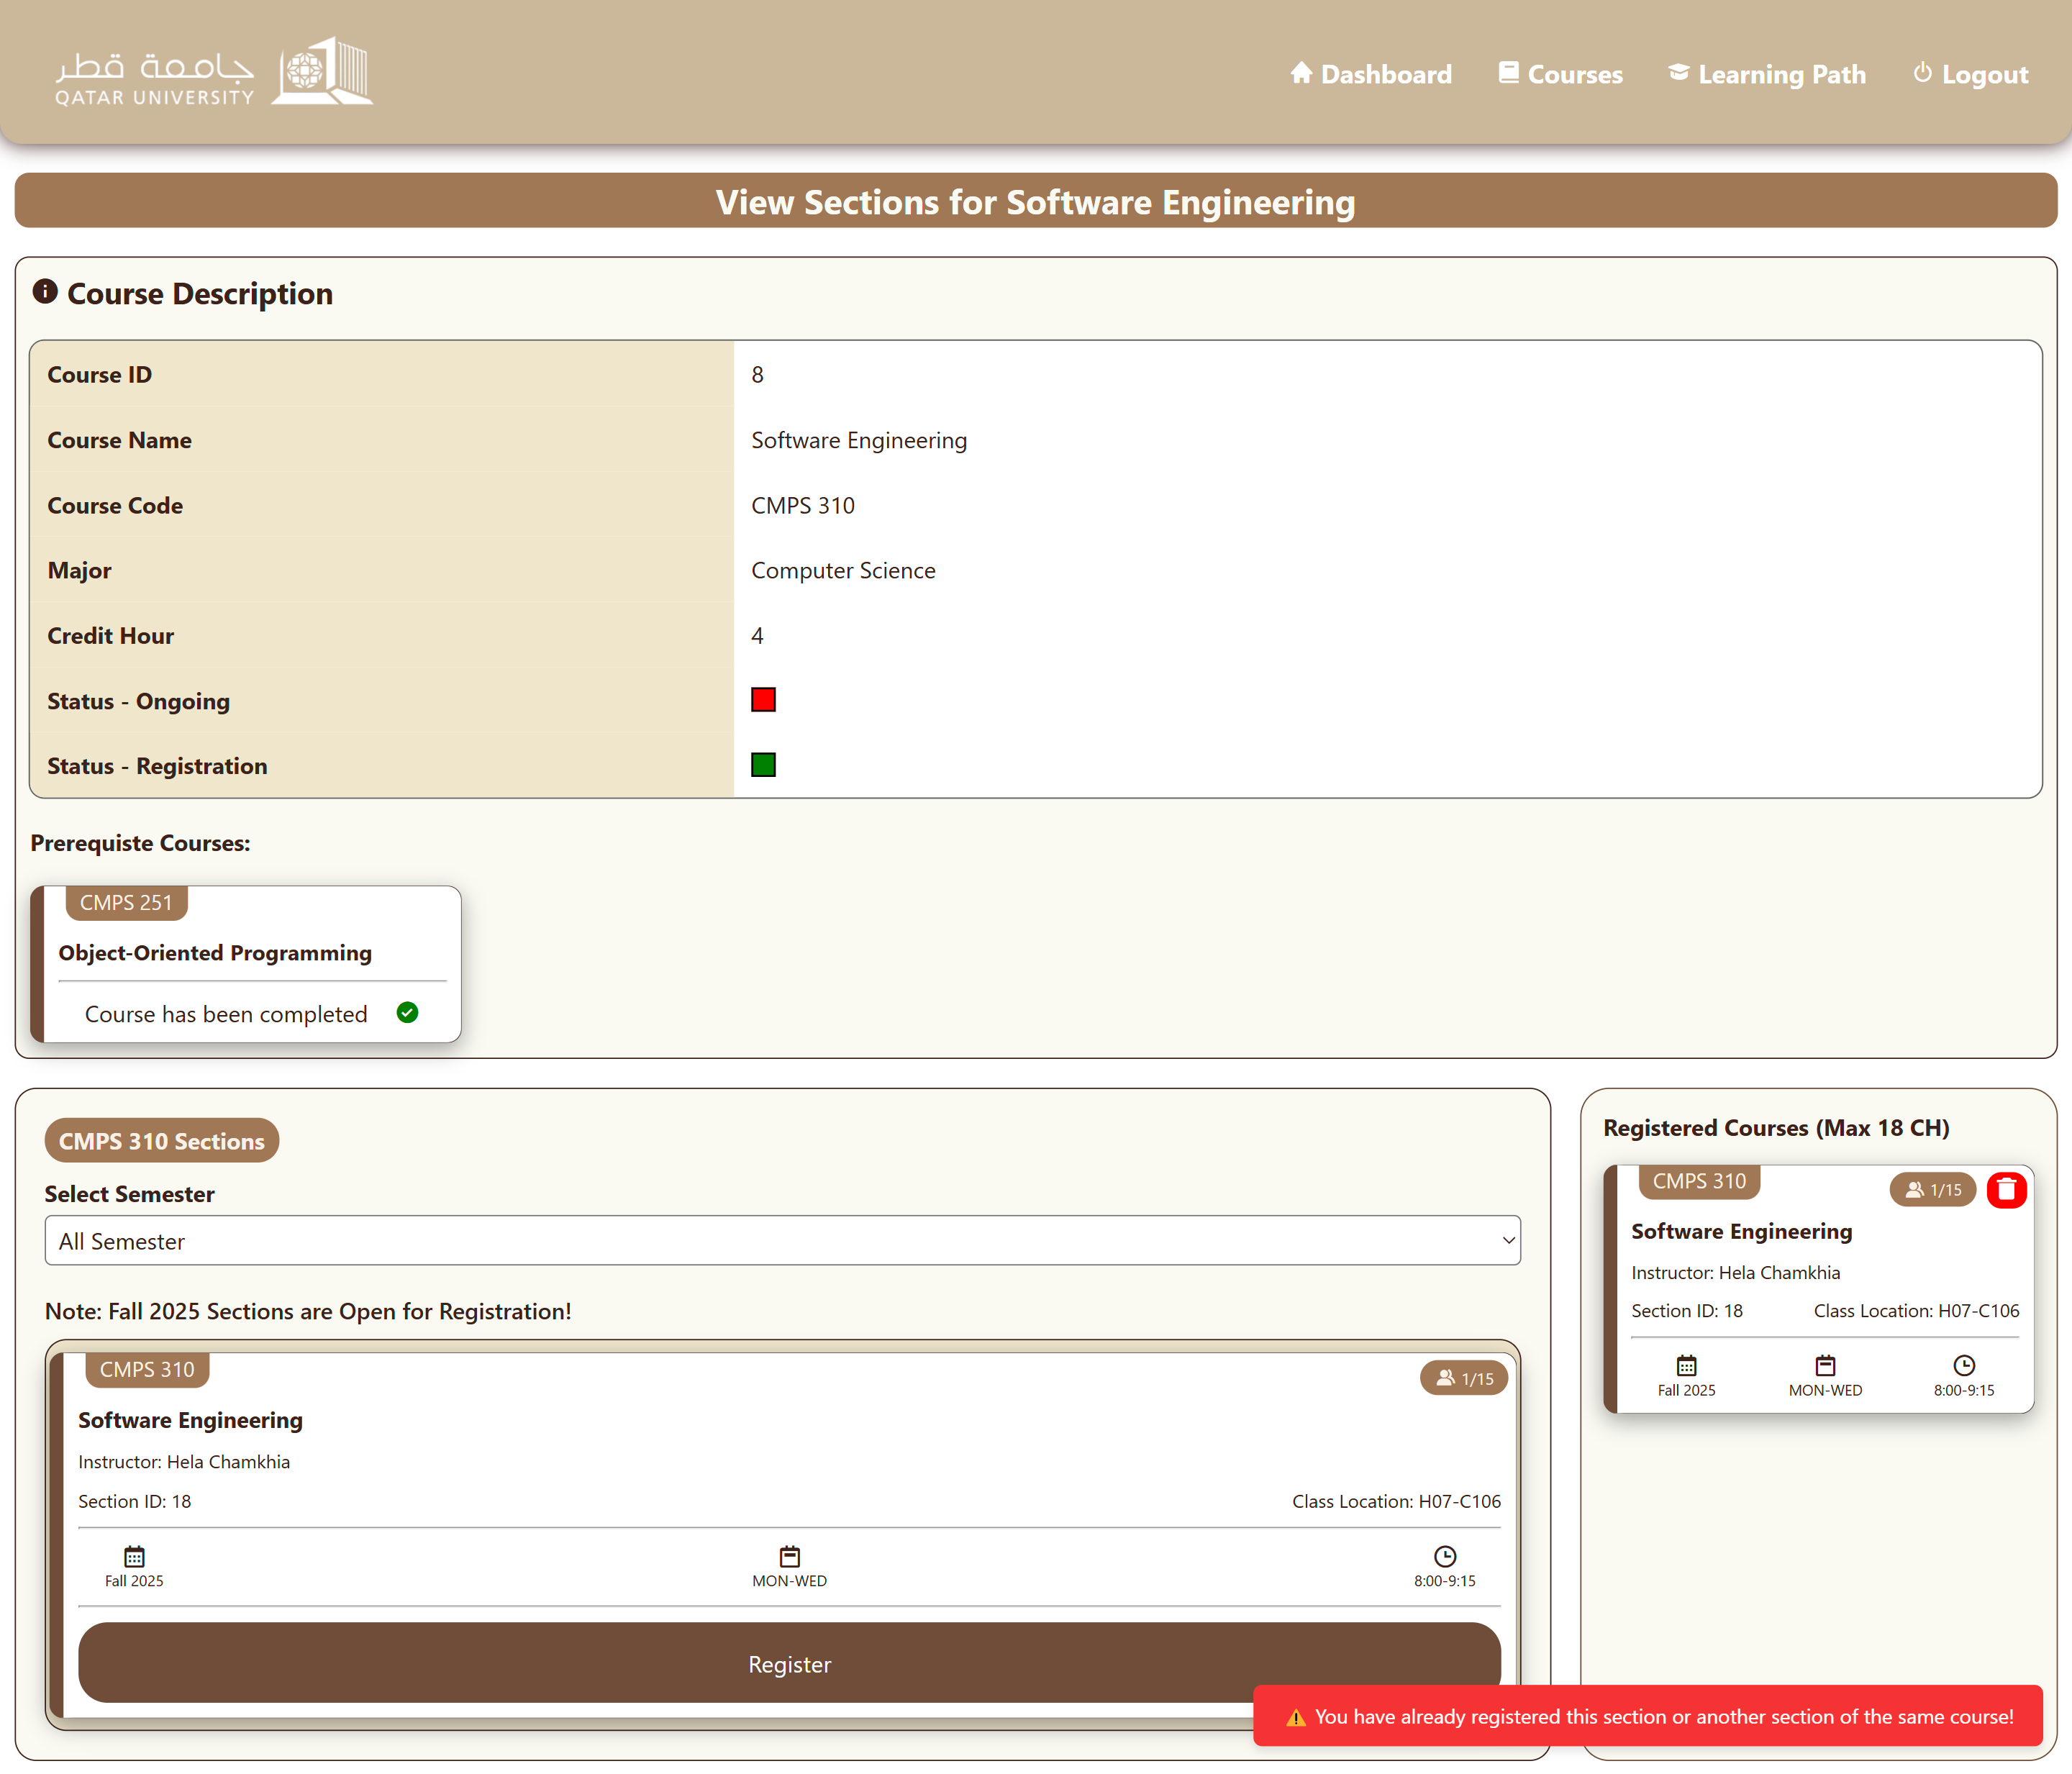Registering for a course that the student has already registered for:

Registering for a course without completing its prerequisites:

Registering for a course that the student has already passed:

Registering for a course not in course plan:

Registering for a course with time conflict:

Error showing that the student is not allowed to register over 18credits:

# Use case 4

Mobile View & Laptop View:

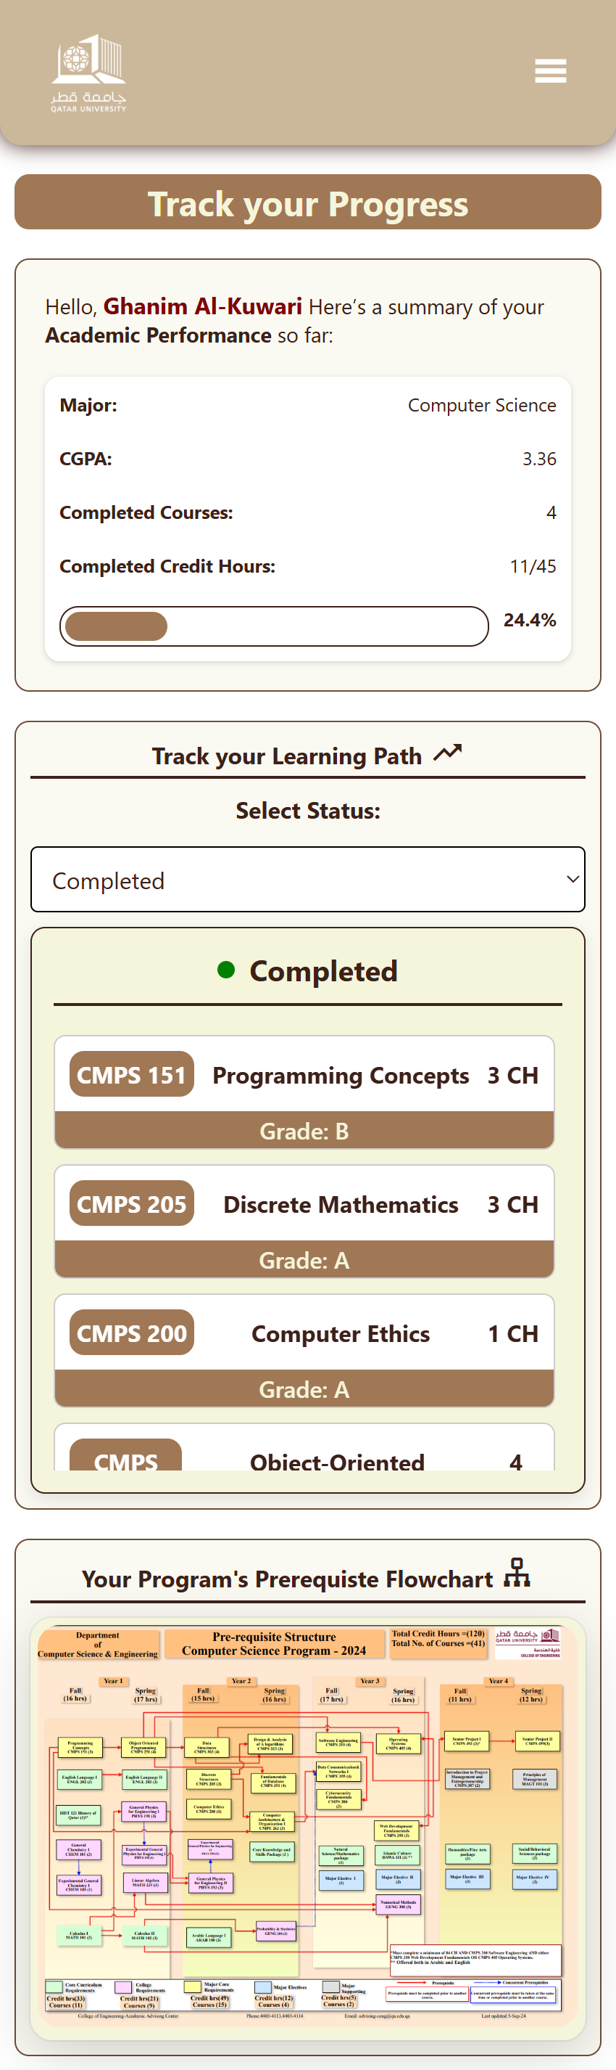 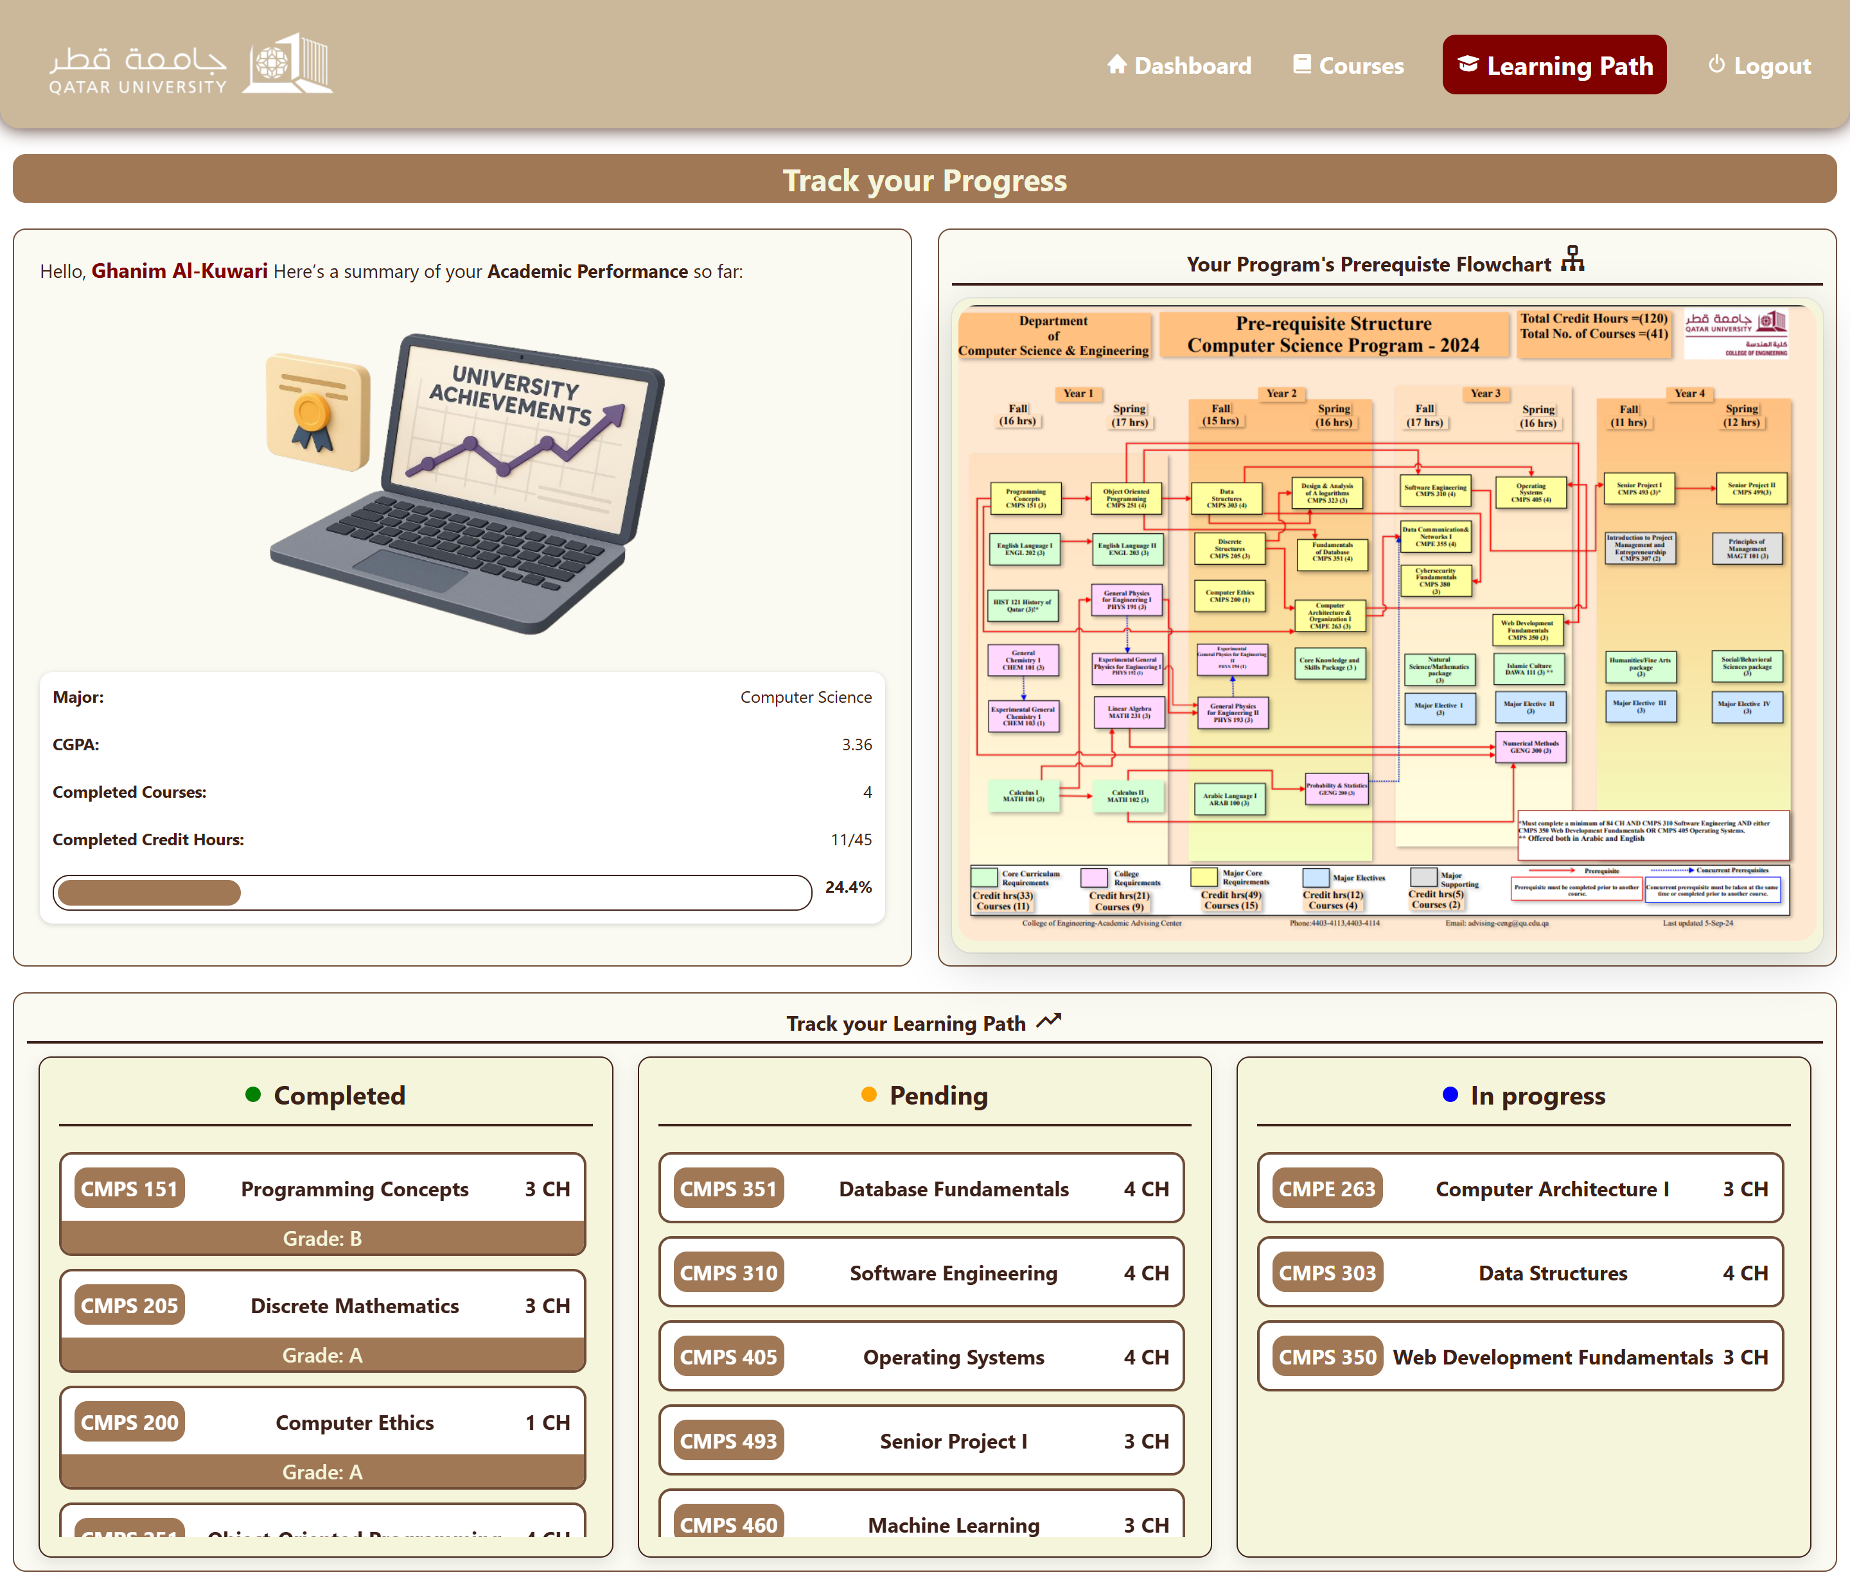

# Use case 5

Admin Dashboard Laptop View & Mobile View:

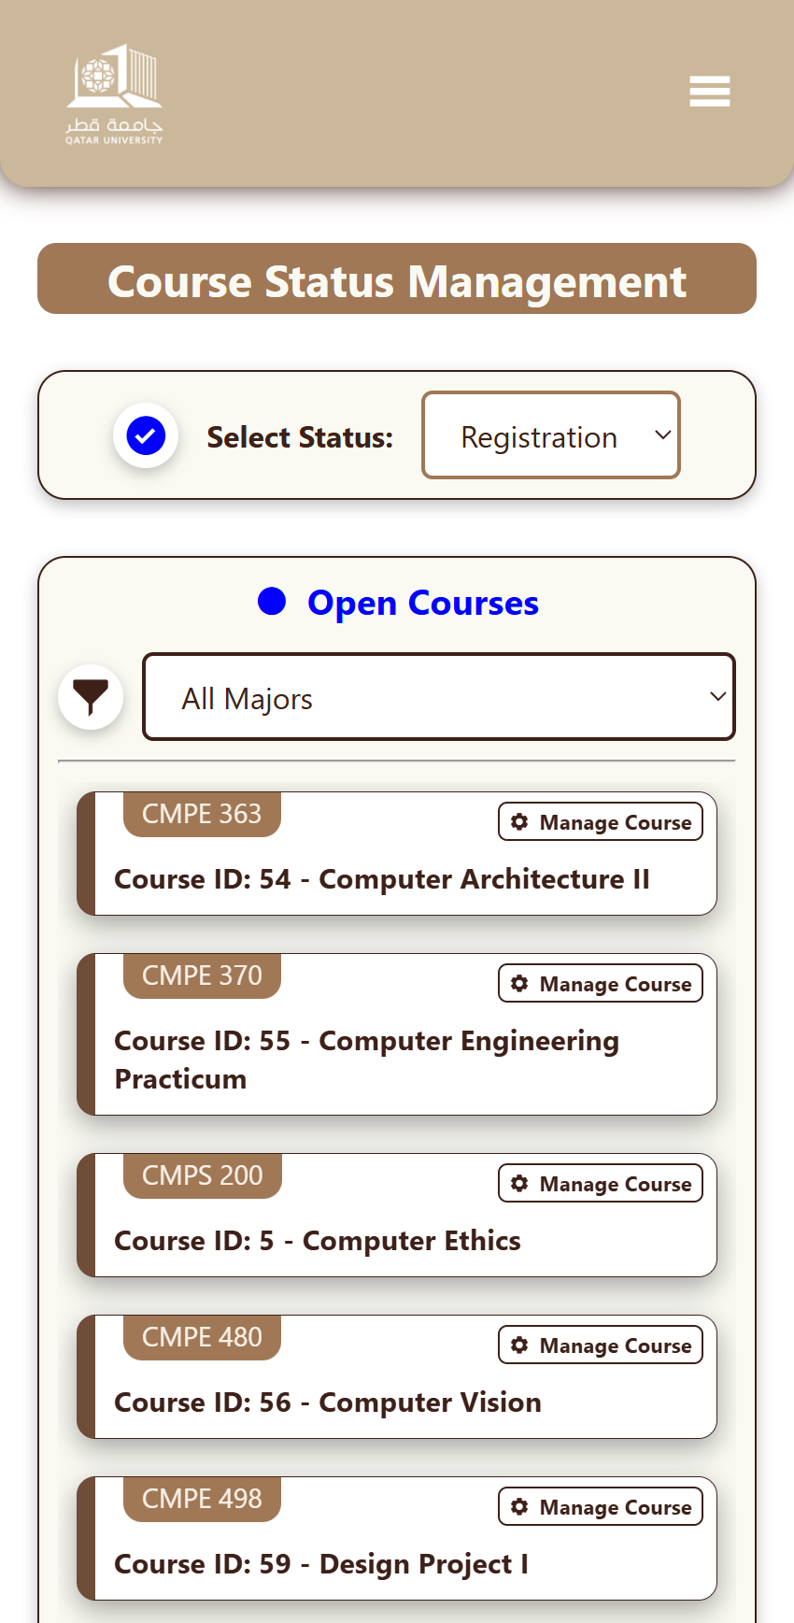

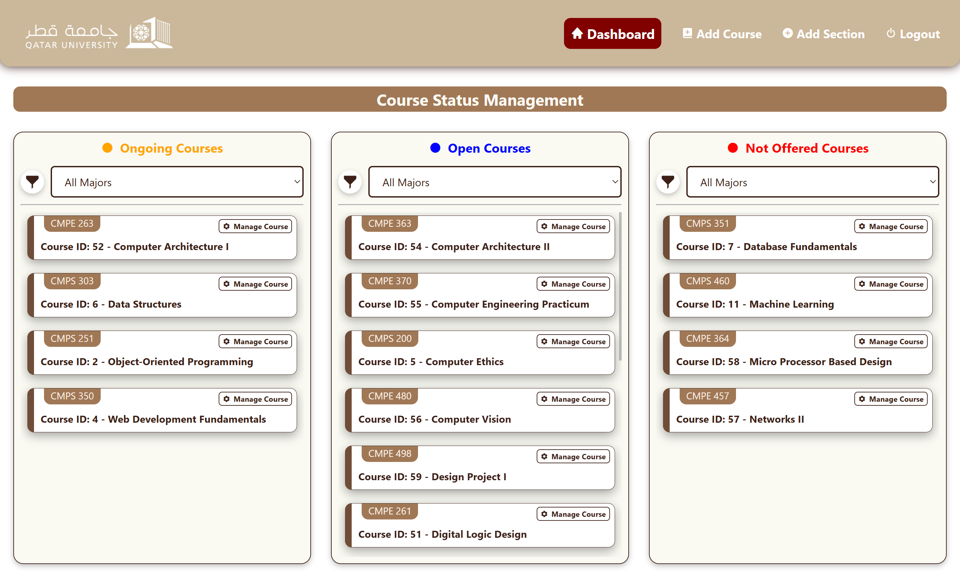

View Sections (Programming Concept):

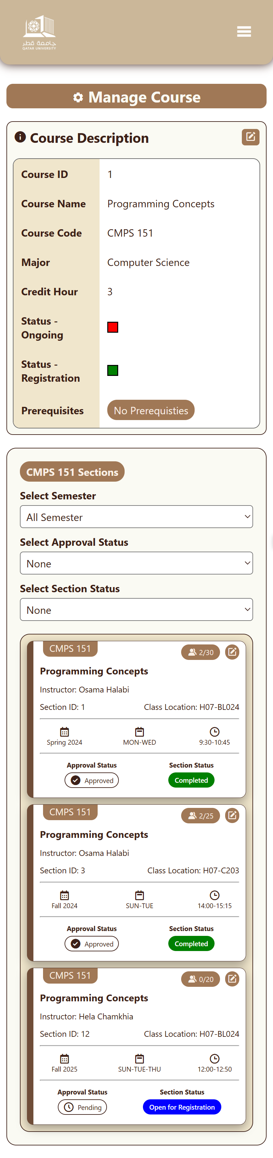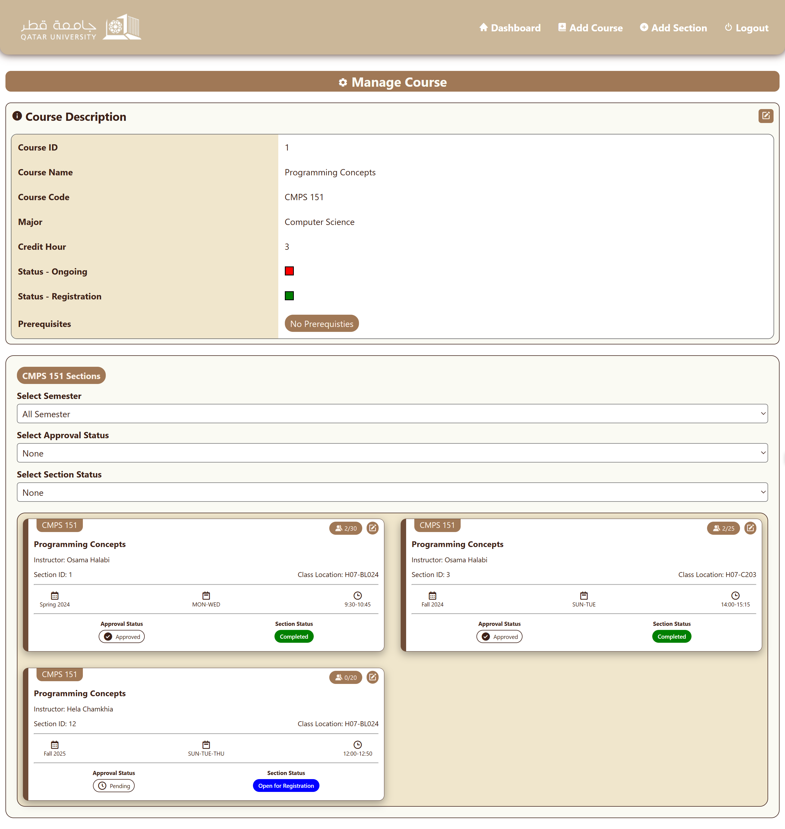

Section Validation (Before Validating):

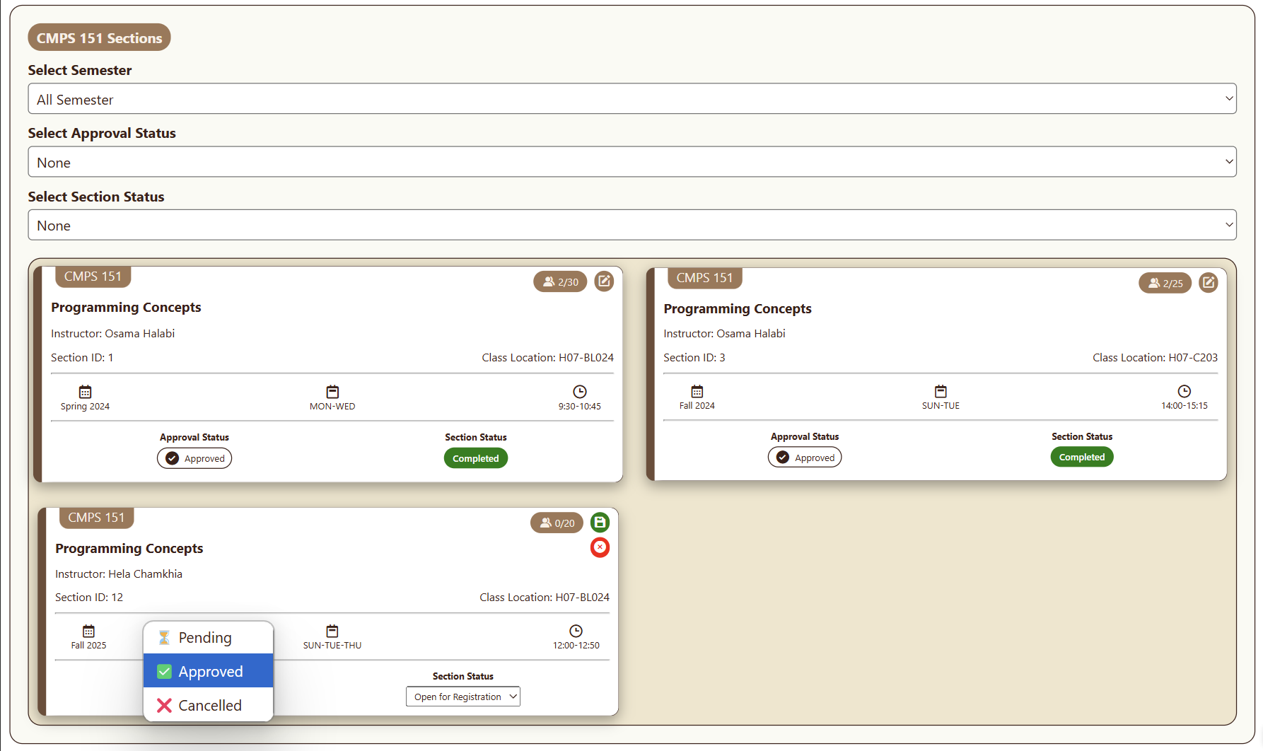

Section Validation (After Validating):

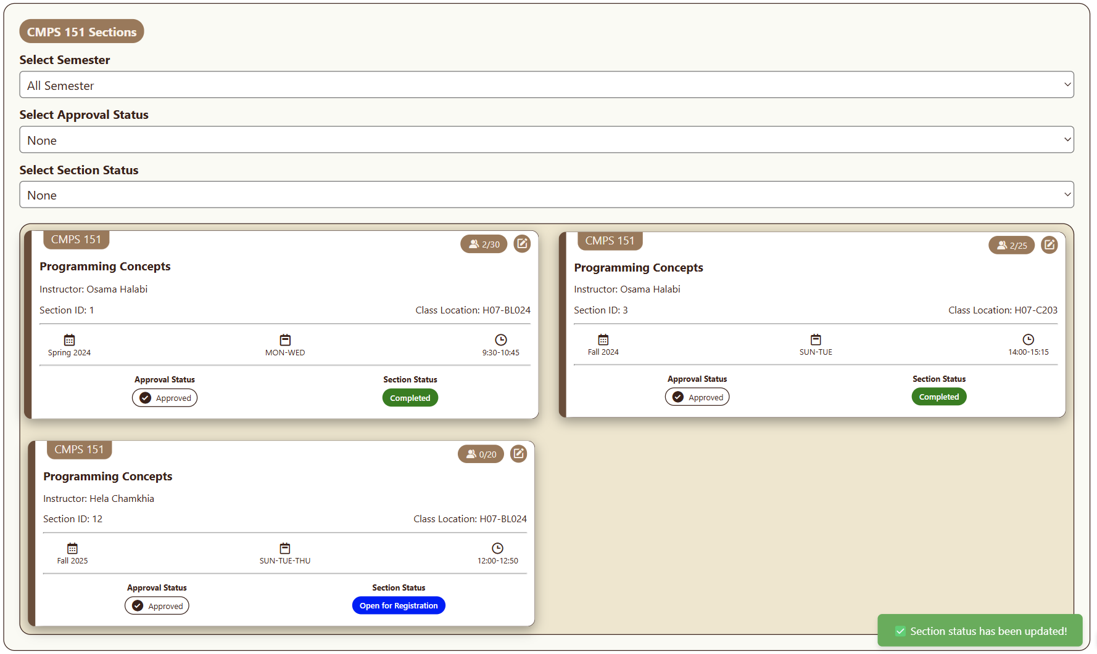

Cannot Start Section (Because it’s not approved yet):

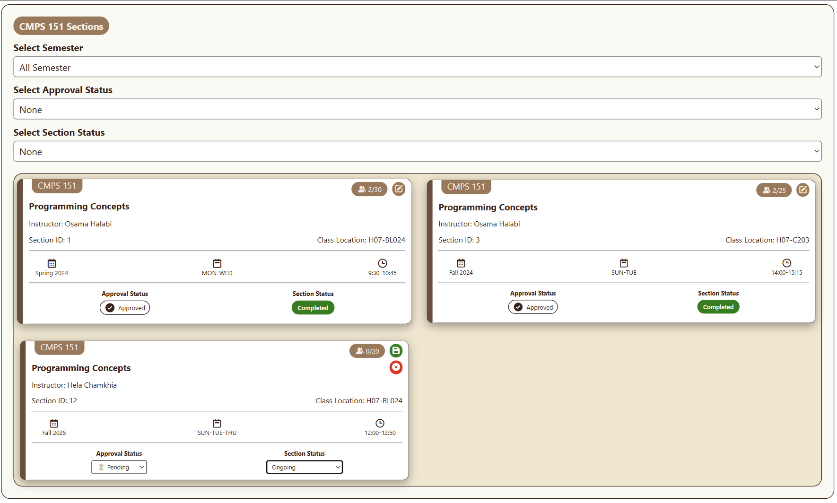

Attempting to Start a Section when it’s not approved yet:

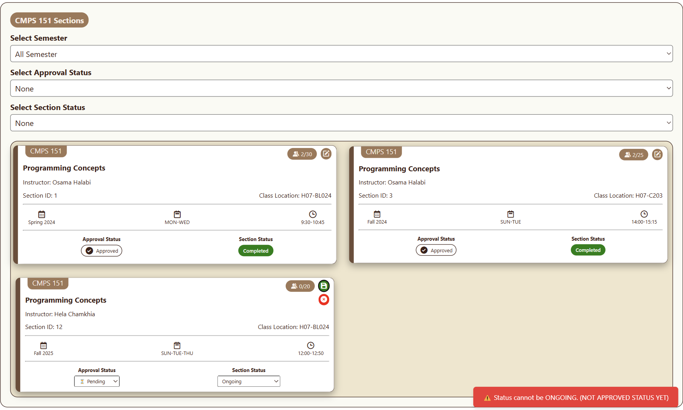

Starting Section because it’s approved (Part 1):  
 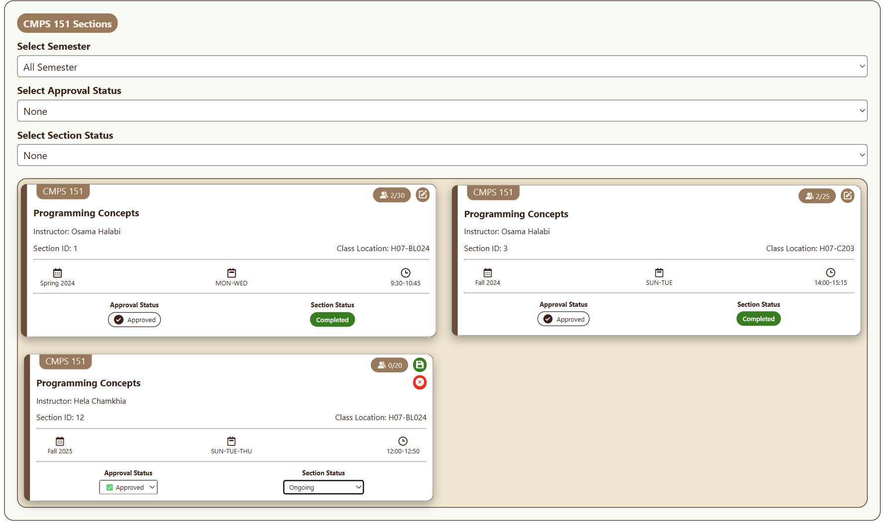

Section Starting because it's approved (Part 2):

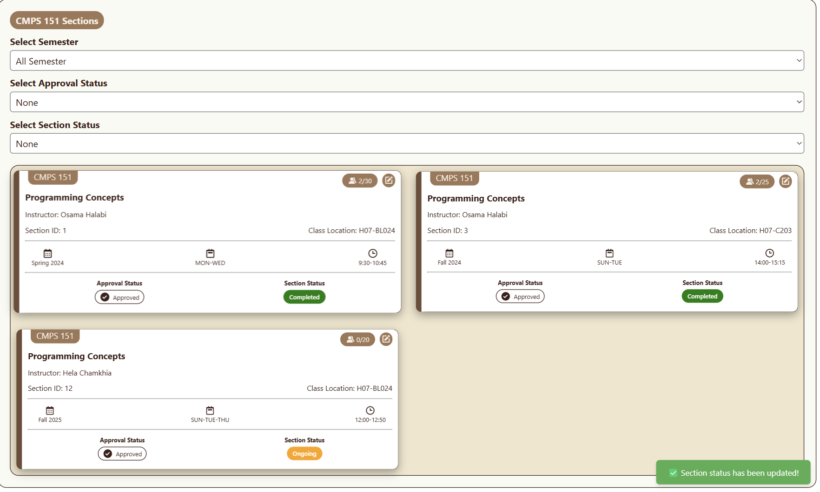

Failed to add course because Credit Hour is 0 or below:

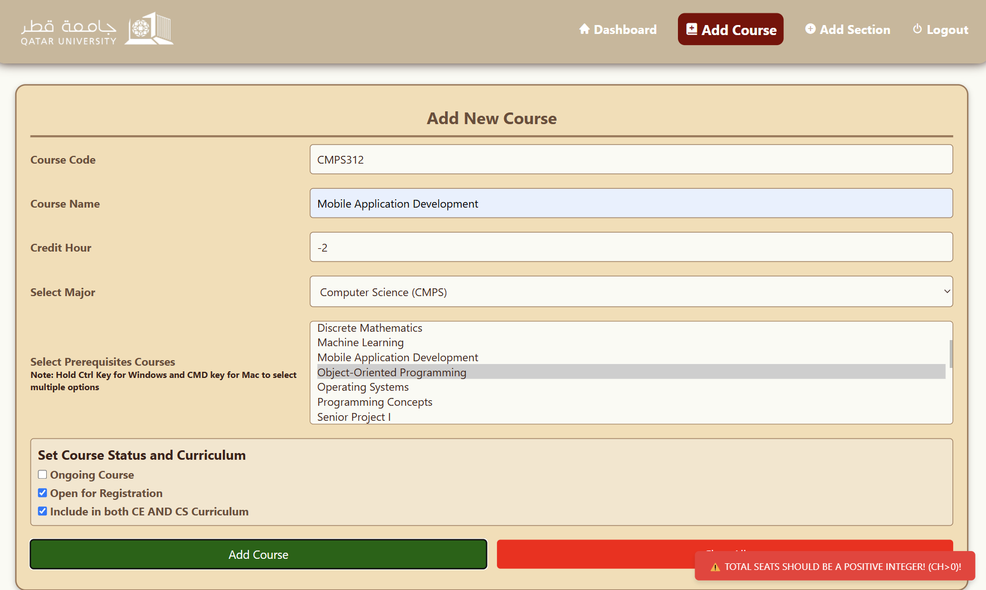

Failed to add course because Course already exist:

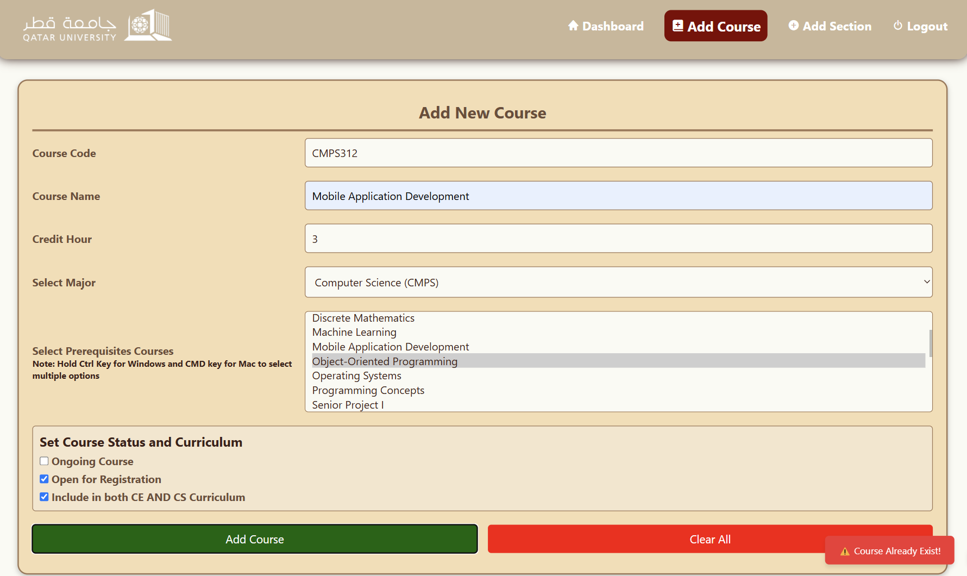

Adding a new course (Part 1):

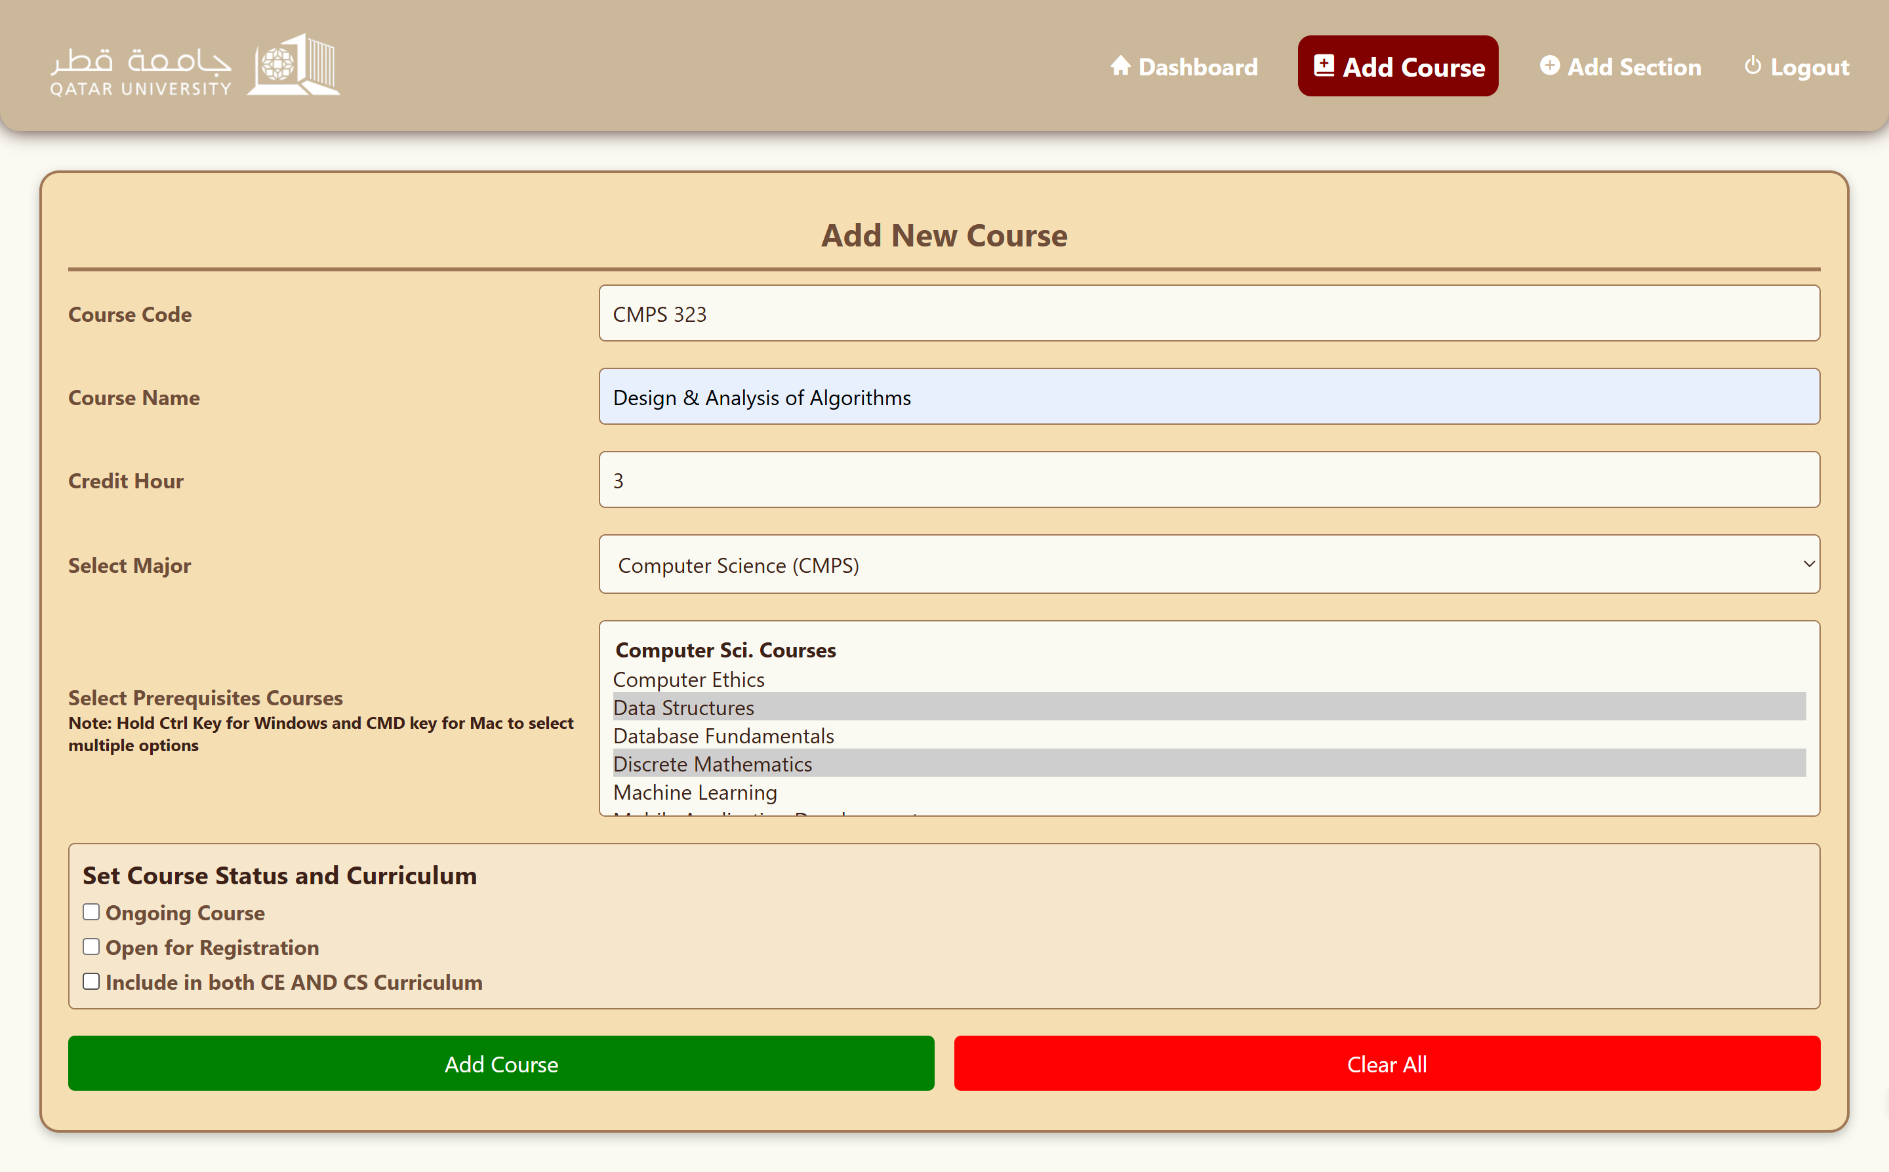

Adding a new course (Part 2):

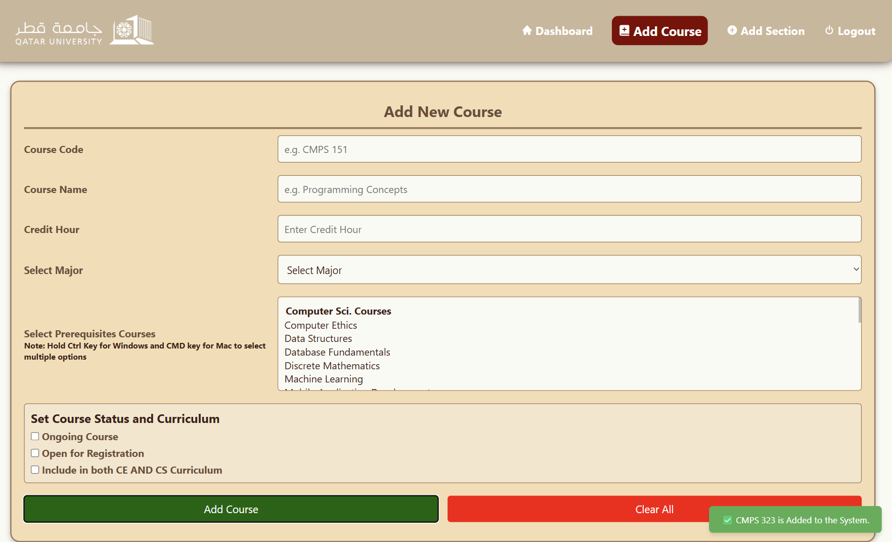

Failed to add section because seats are 0 or below:

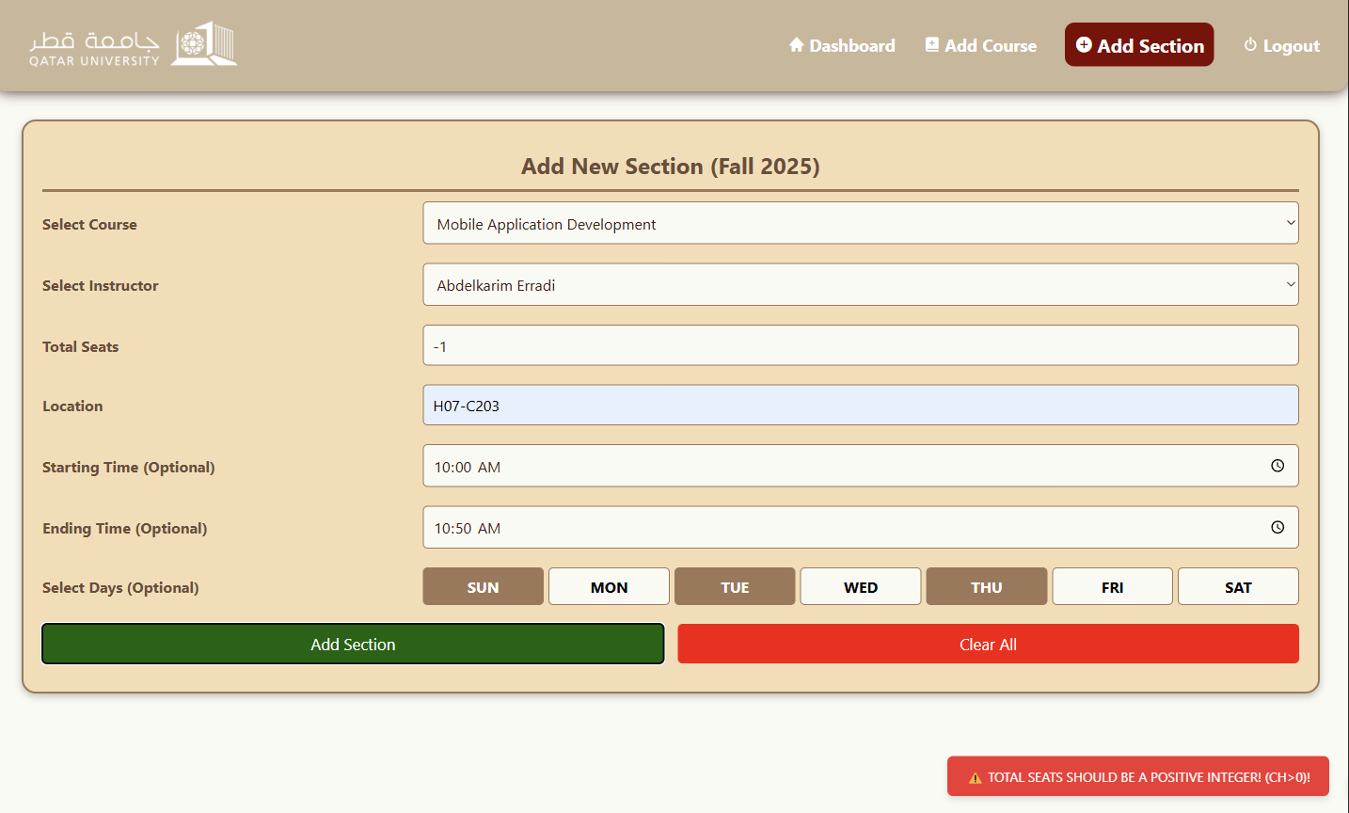

Added a new section for CMPS 312 (Part 1):

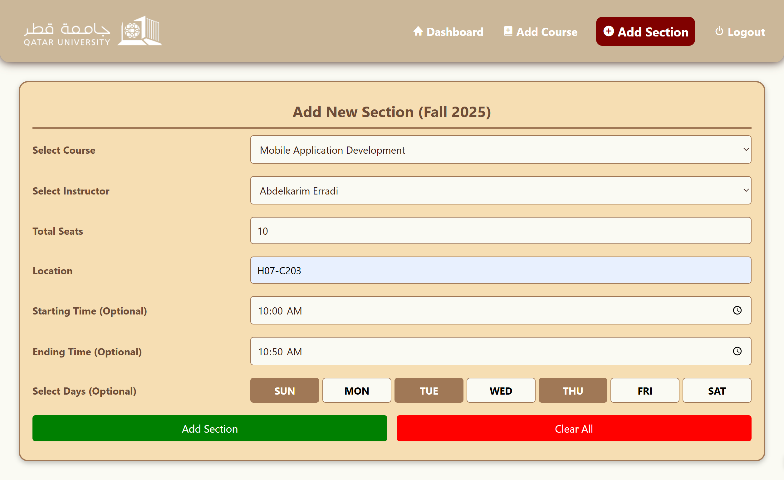

Added a new section for CMPS 312 (Part 2):

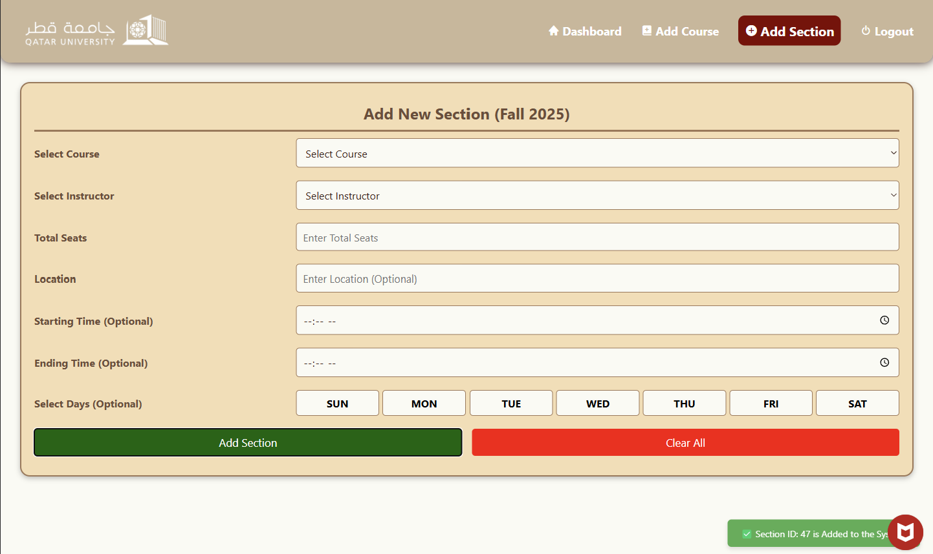

# Use case 6

Normal view of instructor dashboard (Mobile & Desktop):

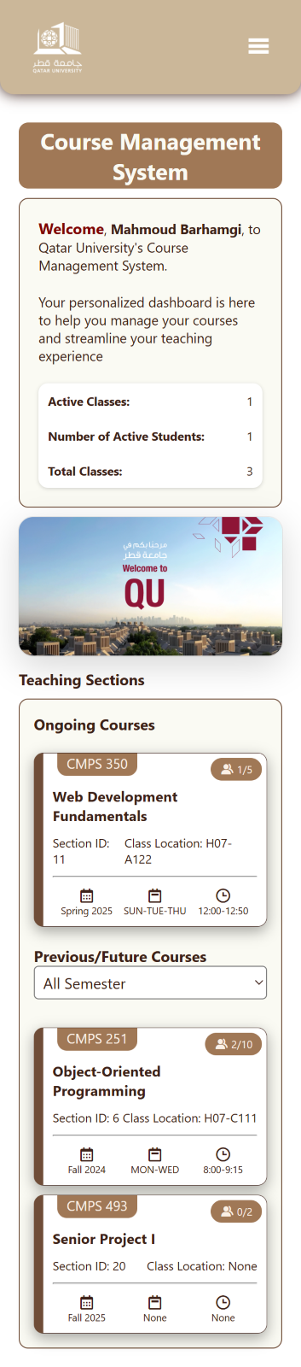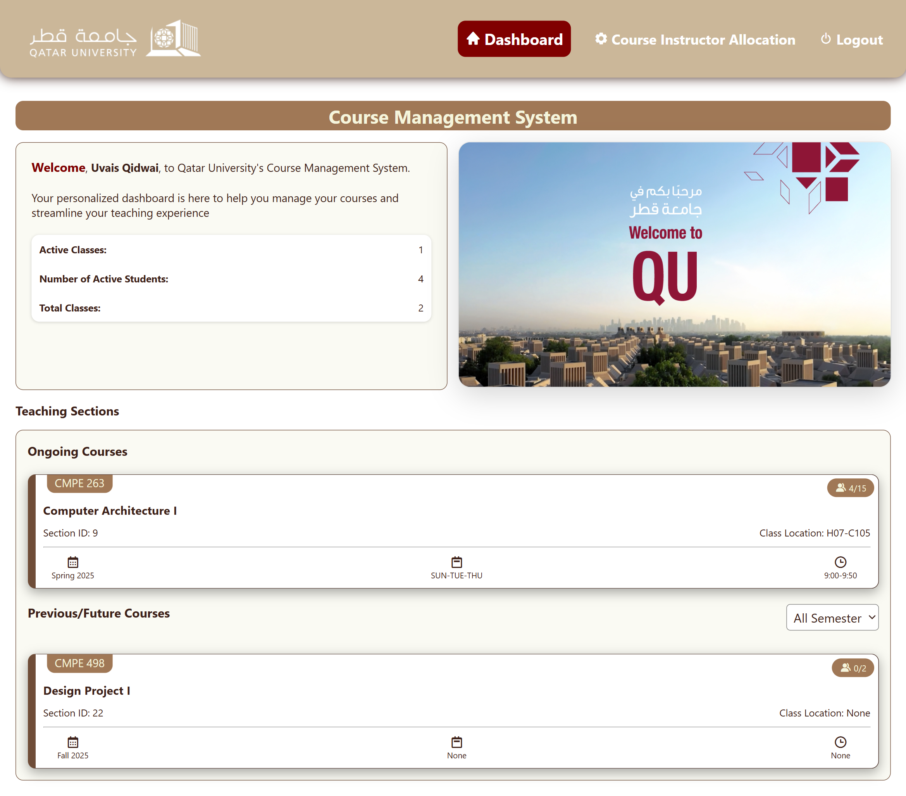

If no sections were found when filtering (Spring 2024 in this case):

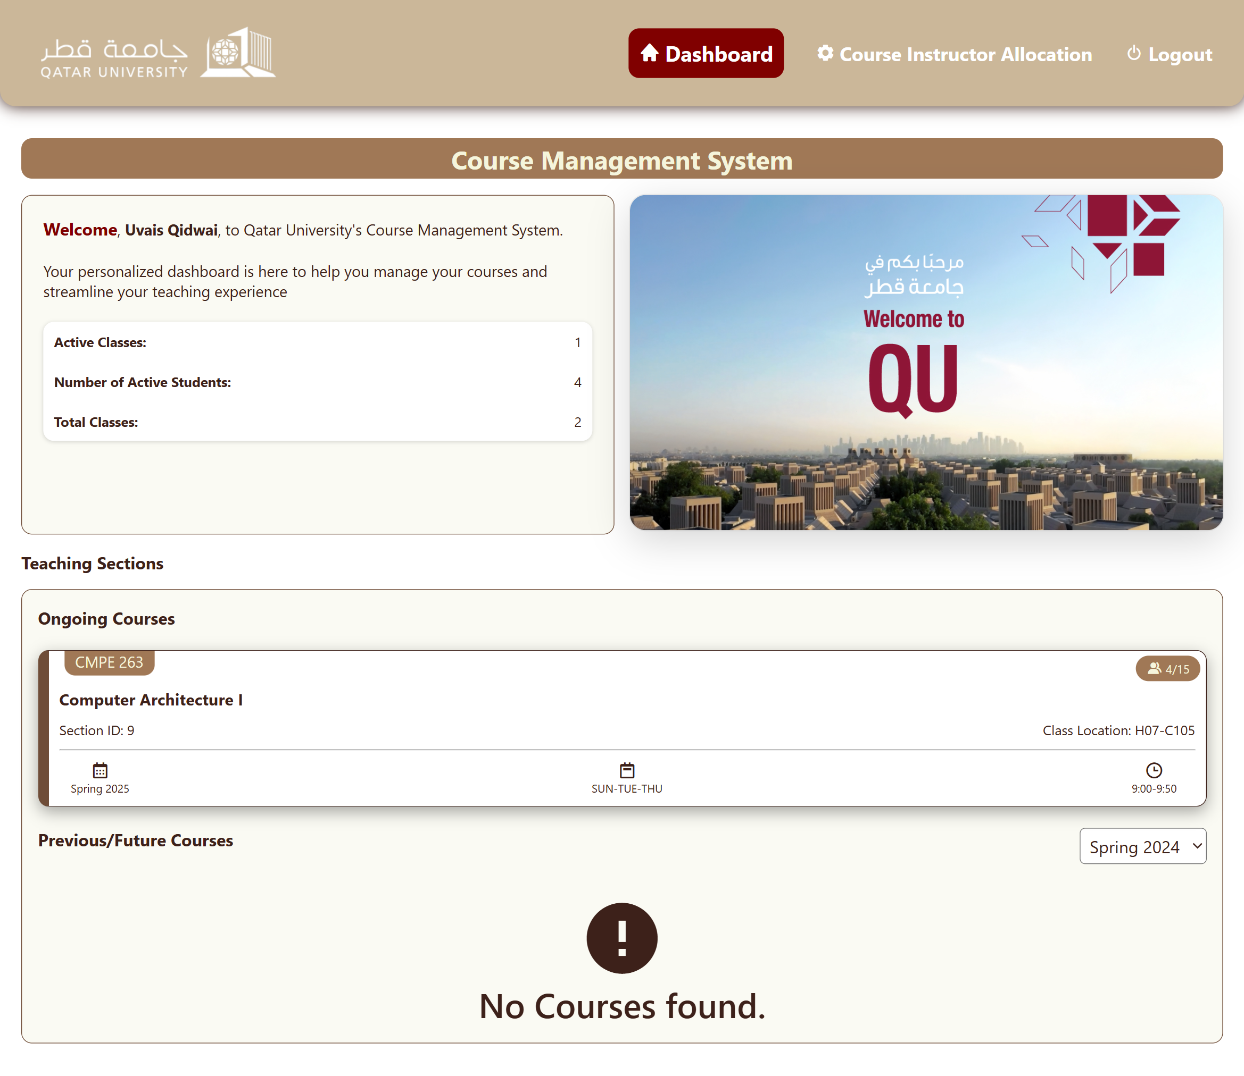

When the Instructor is not currently teaching:

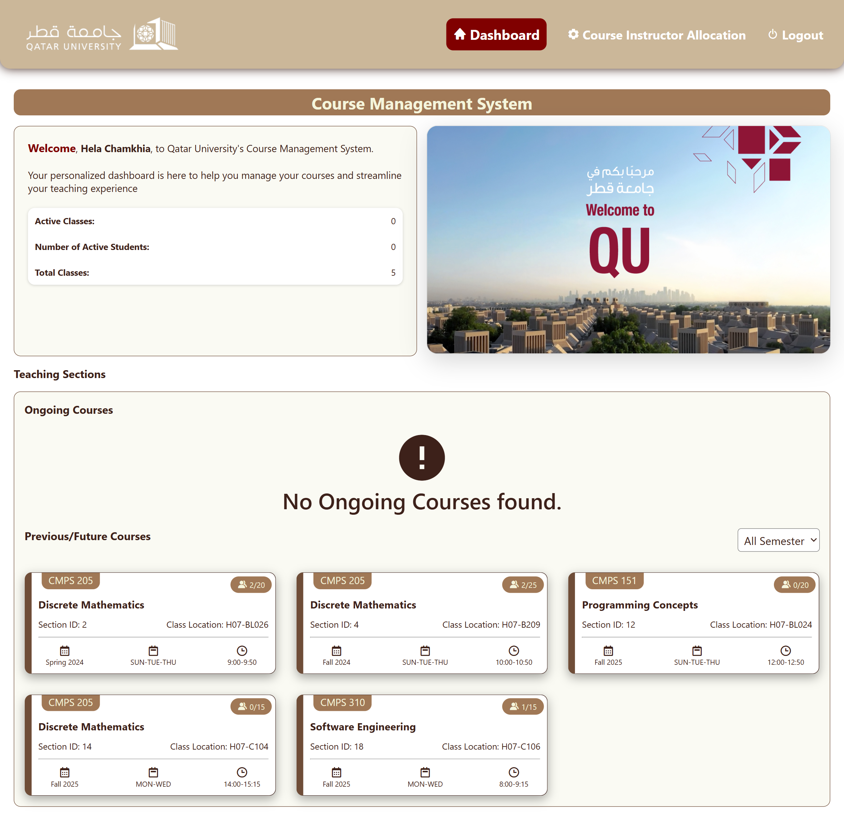

Filtering (Spring2024):

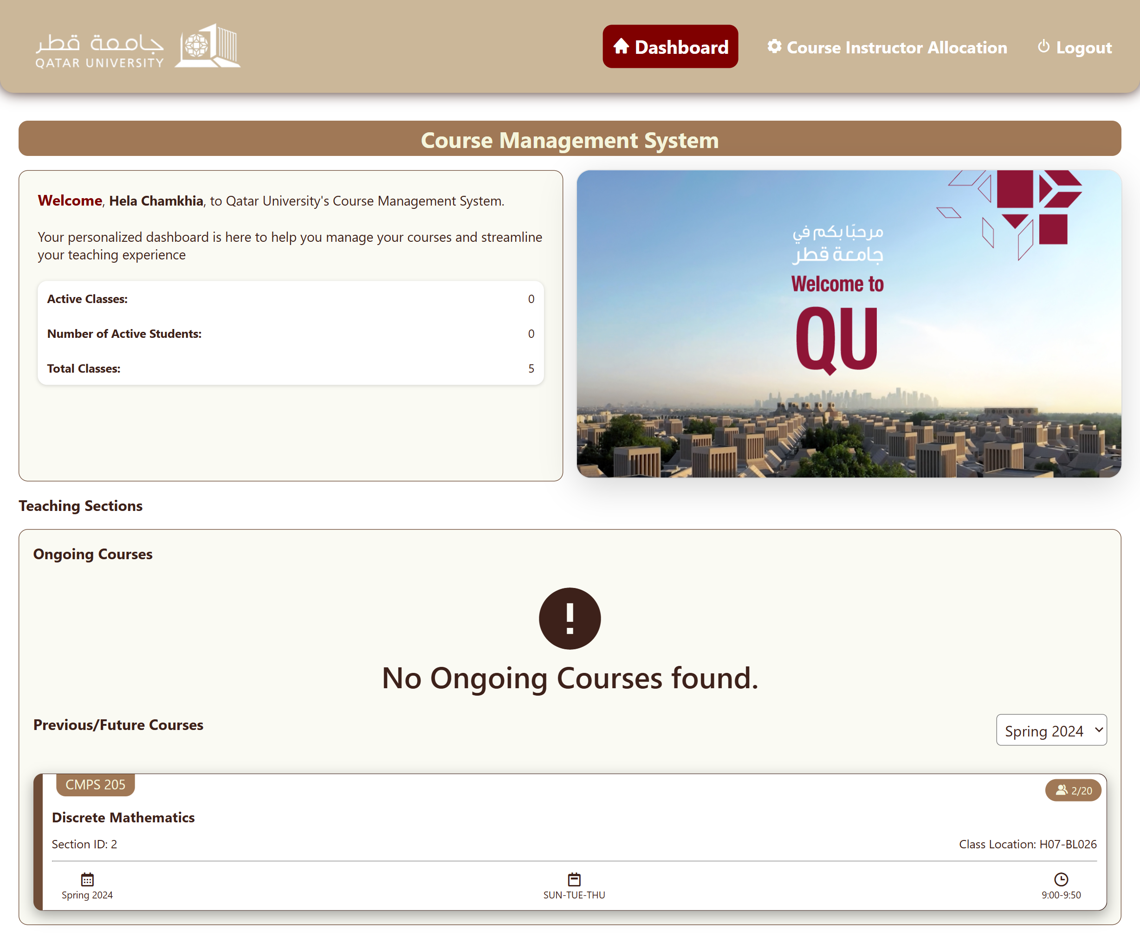

Grade Allocation after clicking on a course (Discrete Math in this case):

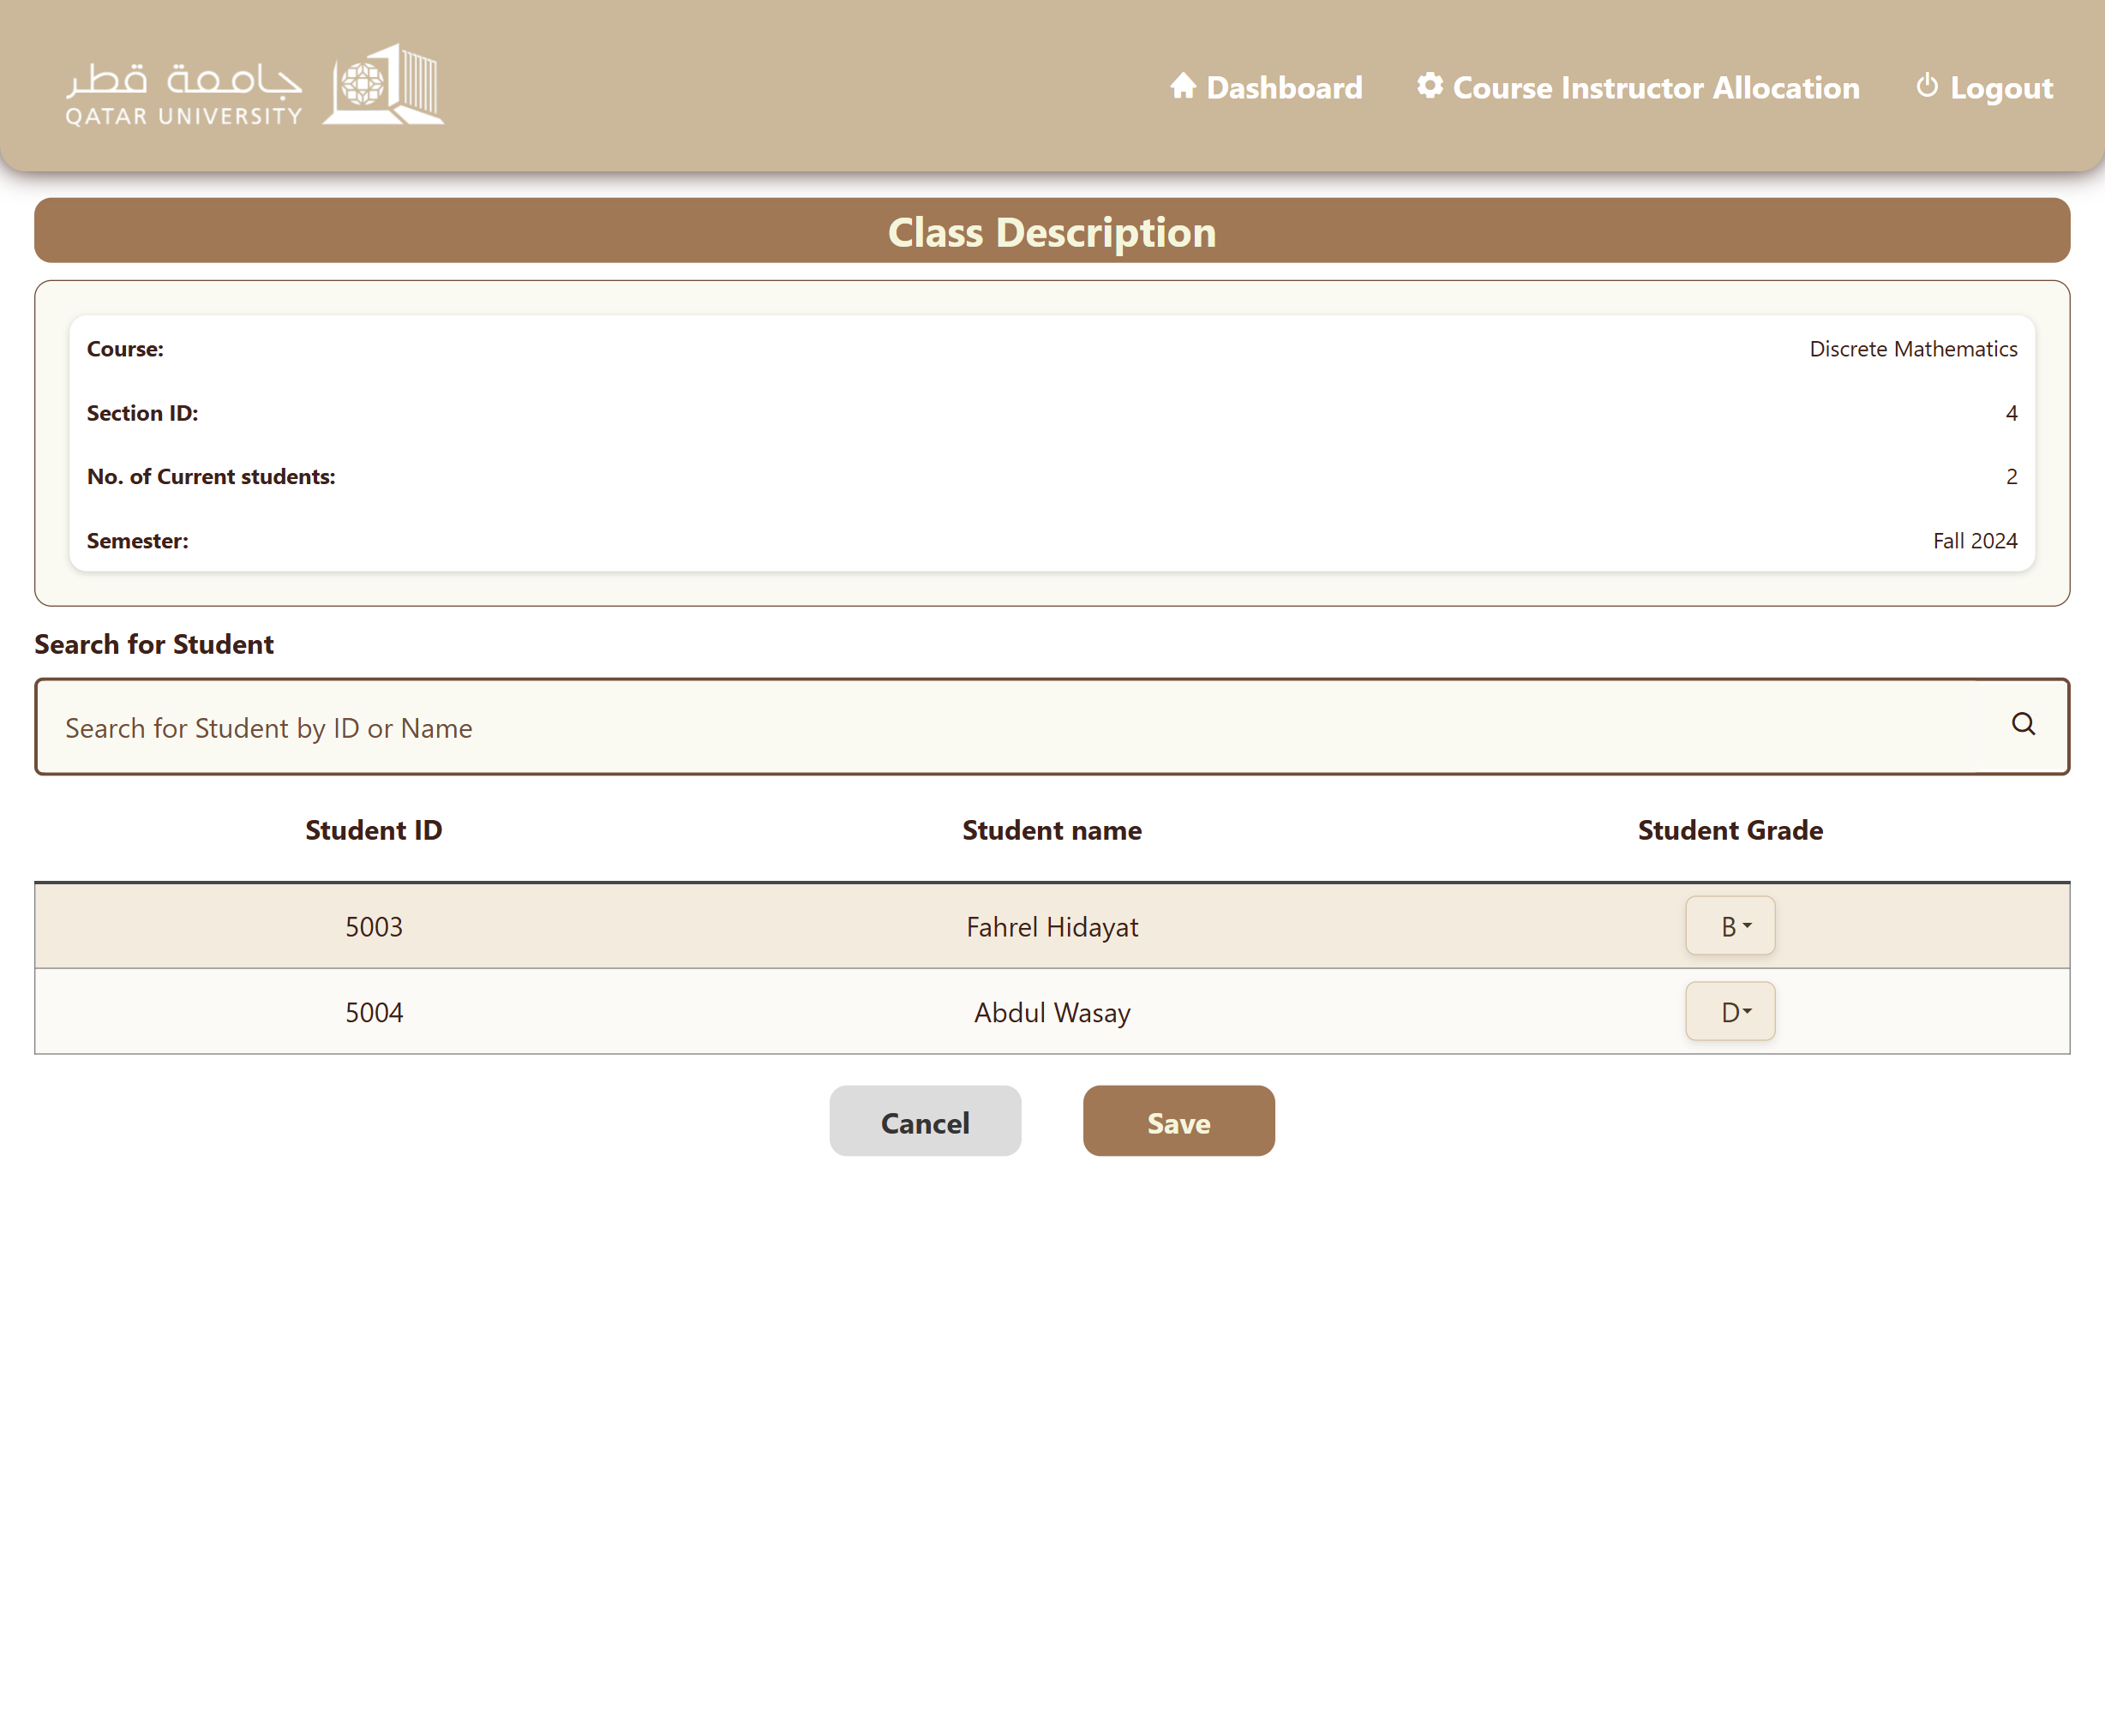

After clicking on Save:

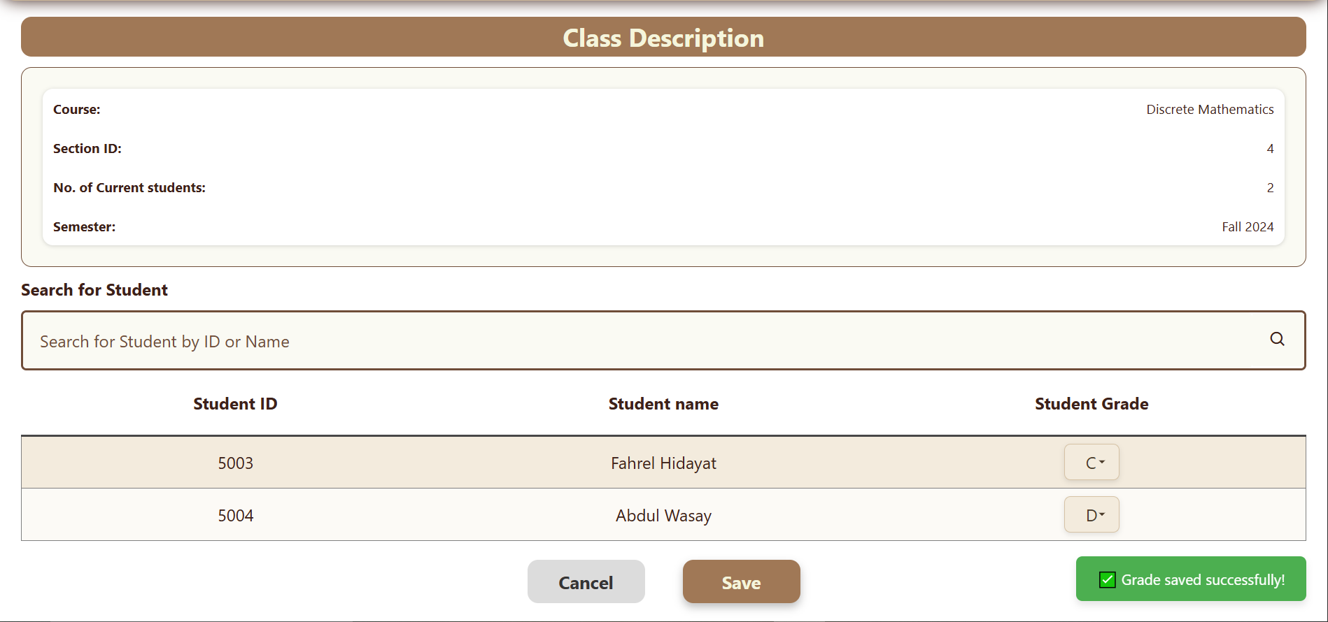

Searching for “B”:

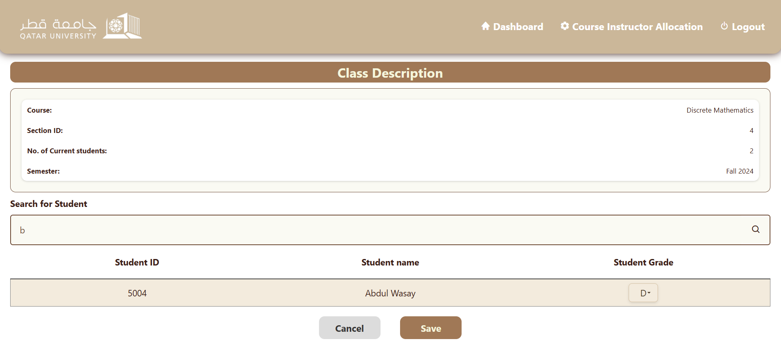

# Use Case 8

Laptop View:

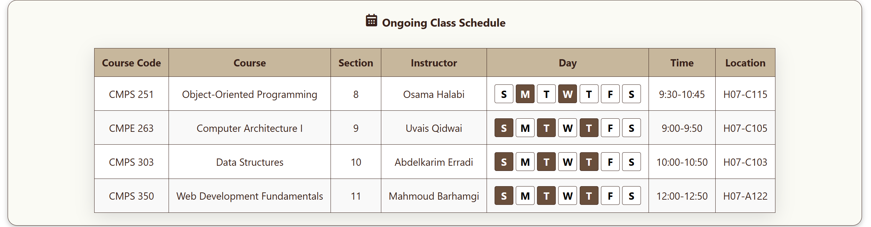

Mobile View: (Scrollable)

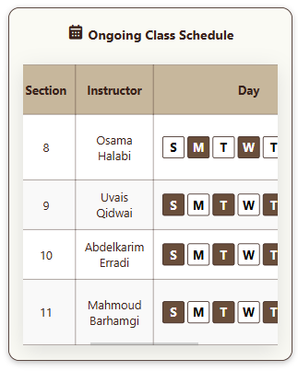

# Discussion of the project contribution of each team member

|  |  |
| --- | --- |
| **Student name** | **Student contributions** |
| Ghanim Mubarak Alkuwari | Completed use case 4 (learning paths), coded the javascript for use case 1 (login) and Performed Testing of Use Cases |
| Fahrel Hidayat | Completed Use Cases 5, 8 and Assisted with Use Case 3, 6. Led the Styling and set the system’s theme styles. UI sketching and Created Entity Relationship and Use Case Diagram. Performed Testing of Use Cases. |
| Mohammed Mansib Shahriyar Alam | Initial styling for Use Case 1. Helped with the UI styling. Completed full Use case 2 and use case 3. Performed Testing of Use Cases. |
| Abdul Wasay | HTML, CSS and JavaScript for entire use case 6. (Grade allocation and Instructor Dashboard). Changed a few things in UI styling, giving it a sleek and modern look. Made a few general bug fixes around the application. Performed Testing of Use Cases . |